O2 RITZ MANCHESTER ACCESS PROCEDURE
The O2 Ritz Manchester welcomes customers with access requirements. We work alongside Attitude is Everything to continuously improve our access provisions.
*Alternative formats of the Live Access documents are available on request.

BOOKING ACCESIBLE TICKETS
As the O2 Ritz Manchester is a standing venue, we have a limited number of seats available for our access customers. These are available for prior booking with our access team on the below contact details.
Proof of disability is required when booking for the first time. This can be kept on file for future bookings if you complete the access booking form. Our full Essential Companion Policy is here.
Email: access@o2ritzmanchester.co.uk
Tell us what you need and whether you’d prefer a phone call or email. We aim to reply within 5 working days.
Phone: 0161 552 6374
(Available Monday to Friday 12pm-4pm)

ACCESS IN AND AROUND OUR VENUE
Priority entrance is available with level access throughout. The accessible entrance can be found on the right-hand side of the venue. Once doors open (usually 7pm but always check our website closer to the time), you can enter via this entrance. Let security at the front door know if you need this entrance. Our ground floor has step free access. Our balcony has approx. 20 steps and no lift.
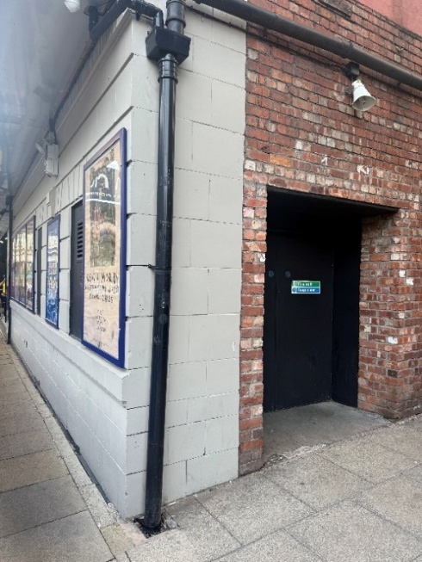
This picture shows our accessible entrance on the right-hand side of the venue. It is a black door with a lowered curb. On a show security will be placed here and able to assist.
ARRIVAL & CHECK-IN
Your tickets should have been emailed to you via Ticketmaster when you booked with the access team. The email comes from Ticketmaster with the subject as “You’re In! Your [Show Name] ticket confirmation”. We encourage you to download the app and have them added to your mobile’s digital wallet for smooth entry to the venue. Once you are scanned in, the Access Liaison will show you to your designated area and tell you about our venue. Should you have requested a companion ticket, this will be available to collect on your arrival from either our box office or a member of our access team.
PARKING AND TRAVEL
Our venue doesn’t have its own parking facilities, but there are bays and street parking locally on Whitworth Street West and Great Marlborough Street close by.
*** Patrons are strongly advised to use official car parks at all times ***
By train: The closest railway station is Manchester Oxford Road (MCO), which is about ten metres away, opposite the venue. Accessible facilities are at all of these stations, so please use the links below for more details. Manchester Oxford Road has staff assistance and lifts (but not to Platform 1) and a ramp for train access.
Manchester Piccadilly is the major mainline station in the city, under a mile away. For a handy guide to travelling by train, visit Transport for Greater Manchester. Manchester Piccadilly Station has a large concourse and step free routes, escalators and lifts, with a low-level counter at the ticket office with an induction loop.
By tram: Our nearest Metrolink tram stop is Manchester Deansgate Castlefield, which is about 500 metres away, and there is St Peter’s Square at around 750 metres away. All stops have either a ramp, lift or escalator access.
PERSONAL ASSISTANT (PA) TICKETS
Personal Assistant, or Companion Tickets, are available with valid proof (such as PIP, DLA or the Nimbus Access Card with the +1 symbol present on the card, for other proofs of eligibility, please see our Companion Policy), subject to availability on a 1:1 basis. PA tickets are only available to book directly with the venue by calling 0161 552 6374 or emailing access@o2ritzmanchester.co.uk.
BOX OFFICE
The box office is in our foyer at the front of the venue. There are two steps to this level, but our staff can meet you at the step free entrance and guide you into the box office if needed. The box office is staffed on event nights from around 5pm-9pm. Security staff are also available outside.

GROUND FLOOR ACCESS AREA
There is an access area separated from the general admission audience with tensa barrier. This area is reserved for customers who are wheelchair users or customers who require seating on the ground floor. Located in this area is our wheelchair accessible counter, on the left of the screen.
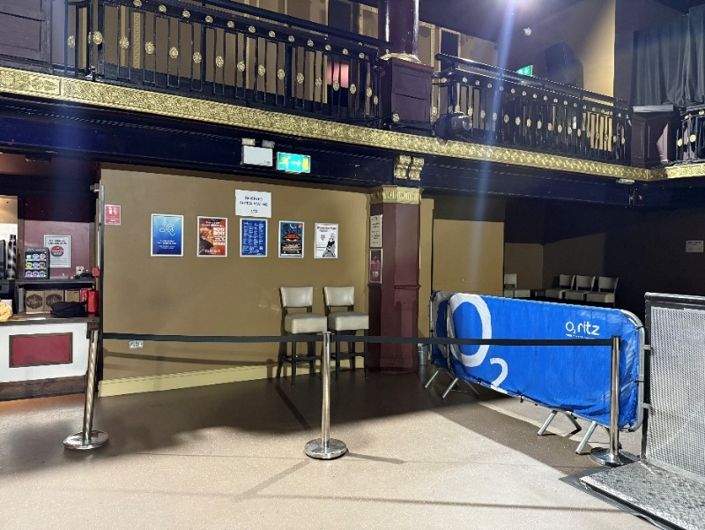
This photo shows our ground floor access area, located in house left of the main room, it has a black tensa barrier around it and is located next to the accessible toilet.
BALCONY ACCESSIBLE AREA
Upstairs on our balcony we have an access platform for customers who require seating. This platform is up 26 steps with no lift access; there are two stairwells coming off both foyers. On this level you can also find a bar and toilets.
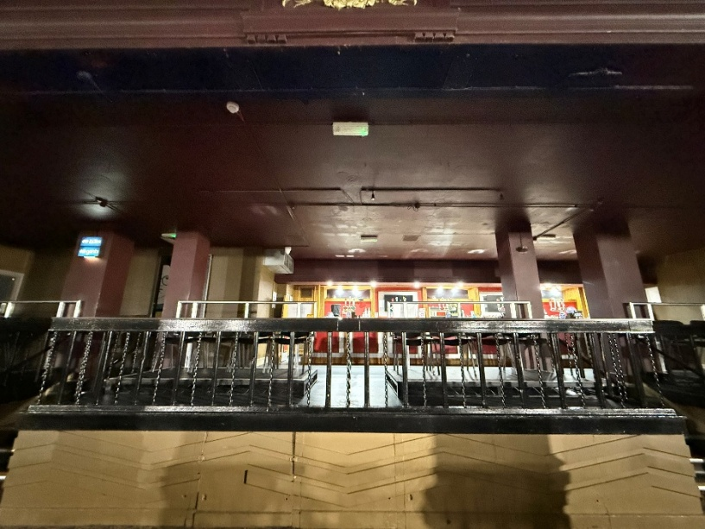
This Photo shows a front facing view of our accessible seating area with a row of chairs placed facing the stage from our balcony level (total 20 steps to the balcony level).
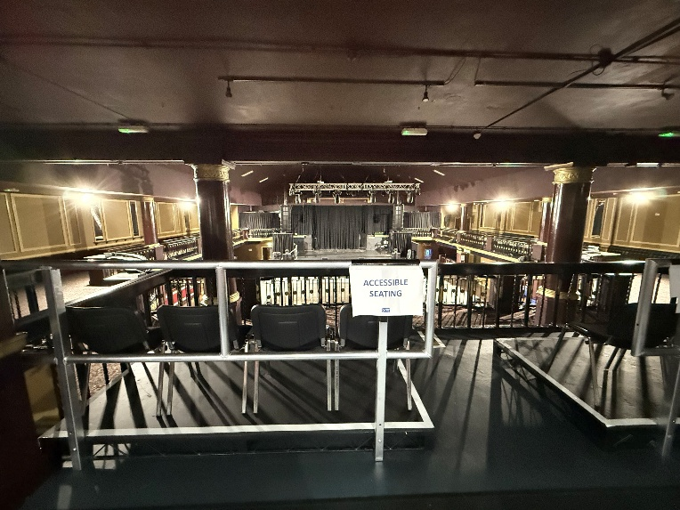
This photo shows the chairs available in our seating area, and the view of the stage (total 26 steps to the balcony seating level).
ACCESSIBLE TOILET
We have one unisex accessible toilet on the right side of the ground floor accessible area and behind the blue O2 barrier. It is step-free and kept locked. Ask the member of our security stood in this area for access to this, they have a radar key.
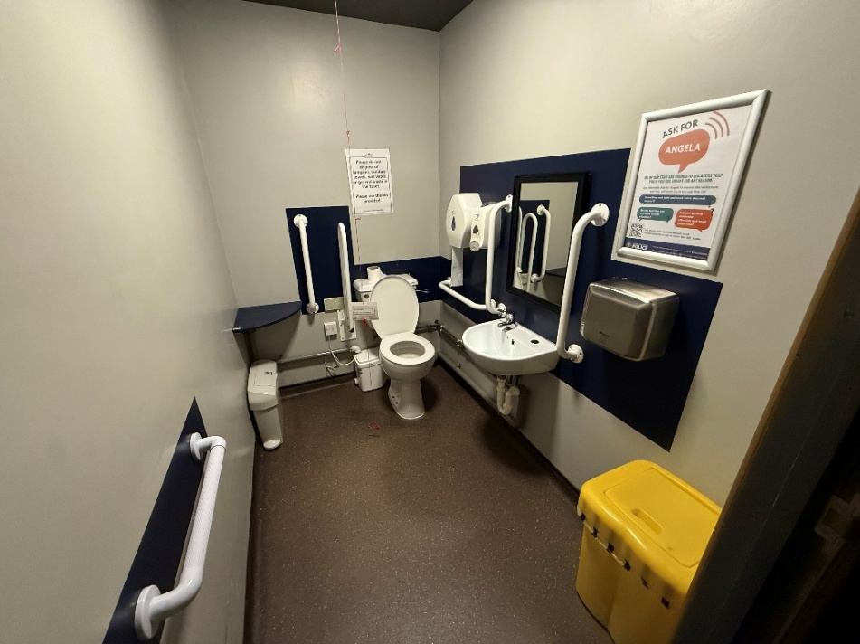
This photo shows our accessible toilet facilities.

HEARING LOOP
There are no permanent hearing loops in the main auditorium, but there is a permanent hearing loop available in the box office.
ASSISTANT DOGS
We welcome assistance dogs in our venue. Please let us know in advance. We can look after your dog in a quiet office for the evening or you are welcome to keep them with you if required.
STROBE LIGHTING
Most shows include strobe or bright lighting. Signs will be up if there’s a lot of strobes in use. Contract us if you have any concerns.
MEDICAL SERVICES
RMS (Remote Medical Services) medical staff are present at all events. They can be found in the first aid room or just speak to any member of staff for help, and we will contact them for you. You’re welcome to bring medicine, food, drink, or equipment to manage a medical condition. Please let us know ahead of time if you can, on 0161 552 6374.
SMOKING AREA
If you need to smoke, staff can help you exit and return to the venue during the event. Please just let us know and we can help arrange this for you.
EXITING THE VENUE
When the show finishes, we recommend that you wait a little while before leaving. This will help you avoid the busy crowds. Should you need assistance in leaving the venue please speak with a member of our staff who will assist you.
Please ask us if you need any help with directions, calling a taxi or any general assistance with leaving the venue.
FEEDBACK
We value all feedback at the venue as it helps to continuously improve the experience we offer to all our guests. Following on from your visit we would be grateful for you to leave your feedback here.

