

Live Access at the O2 Apollo Manchester
The O2 Apollo Manchester welcomes customers with access requirements. We work alongside Attitude is Everything to continuously improve our access provisions.
*Alternative formats of the Live Access document are available on request.
Booking Accessible Tickets
As the O2 Apollo Manchester has some reserved seating, all accessible bookings are made directly with the access team prior to booking. Unfortunately, we are unable to amend bookings made elsewhere.
Proof of disability is required when booking for the first time. This can be kept on file for future bookings if you complete the access booking form. Our full Essential Companion Policy is here.
Email: access@o2apollomanchester.co.uk
Tell us what you need and whether you’d prefer a phone call or email. We aim to reply within 5 working days.
(Note: Emails received before tickets go on sale will not be used to allocate tickets.)
Phone: 0161 273 7785
(Available Monday to Friday, 12pm - 4pm. Extended hours to cover show presales and onsales.)
Access in and Around our Venue
Priority entrance is available with level access through the accessible entrance. Once doors open (usually 7.00pm – check this closer to the time on your tickets), you can enter via the side entrance with level access. Let security at the front door know if you need this. The Stalls area has level access. The Circle has about 40 stairs and no lift.
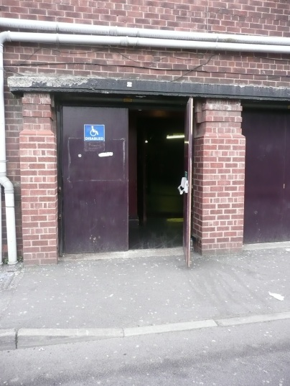
What3Words for the entrance: flight.wounds.weeks
The picture shows an accessible entrance on the Apsley Grove roadside. It is a black door with a lowered curb and a disabled icon sign.
Arrival & Check-In
Your tickets should have been emailed to you via Ticketmaster when you booked with the access team. The email comes from Ticketmaster with the subject as “You’re In! Your [Show Name] ticket confirmation”. We encourage you to download the app and have them added to your mobile’s digital wallet for smooth entry to the venue. Once you are scanned in, the Access Liaison will show you to your designated area and tell you about our venue.
Parking and Travel
Accessible parking spaces are available in the front car park (Hyde Road side). It is run on a first come, first served basis and opens one hour before doors. More parking is available on the opposite side of the building (Apsley Grove side). The car park costs £10 (cash payment only) and is payable to the attendant on the gate. The 192 bus connects the venue with Manchester city centre via Piccadilly Station. The bus stops opposite the venue. Most 192 buses are accessible. Visit www.tfgm.com for more details and to access their journey planner.
Personal Assistant (PA) Tickets
Personal Assistant tickets are available with valid proof (such as PIP, DLA or the Nimbus Access Card with the +1 present on the card, for other proofs of eligibility, please see our Companion Policy), subject to availability on a 1:1 basis. Accessible and PA tickets should be booked together directly only with the venue by calling 0161 273 7785. We are unable to amend bookings made elsewhere.
Box Office
The Box Office is at the front of the building. There are two steps, but there’s a buzzer to speak to staff directly. The Box Office is staffed on event nights from around 5.00pm to 9.00pm. Security Staff are also available outside. What3Words for the box office: flight.wounds.weeks
Stalls Access Viewing Platform (Available on Standing Shows only)
There is a raised viewing platform in rear Stalls (House Right). This is available for wheelchair users and customers who are unable to use stairs to reach the access area in the Circle. One companion can sit with the access customer, and other members of the party can stand nearby. The Access Liaison and a member of security will always be on duty throughout the show.

Accessible Viewing platform:
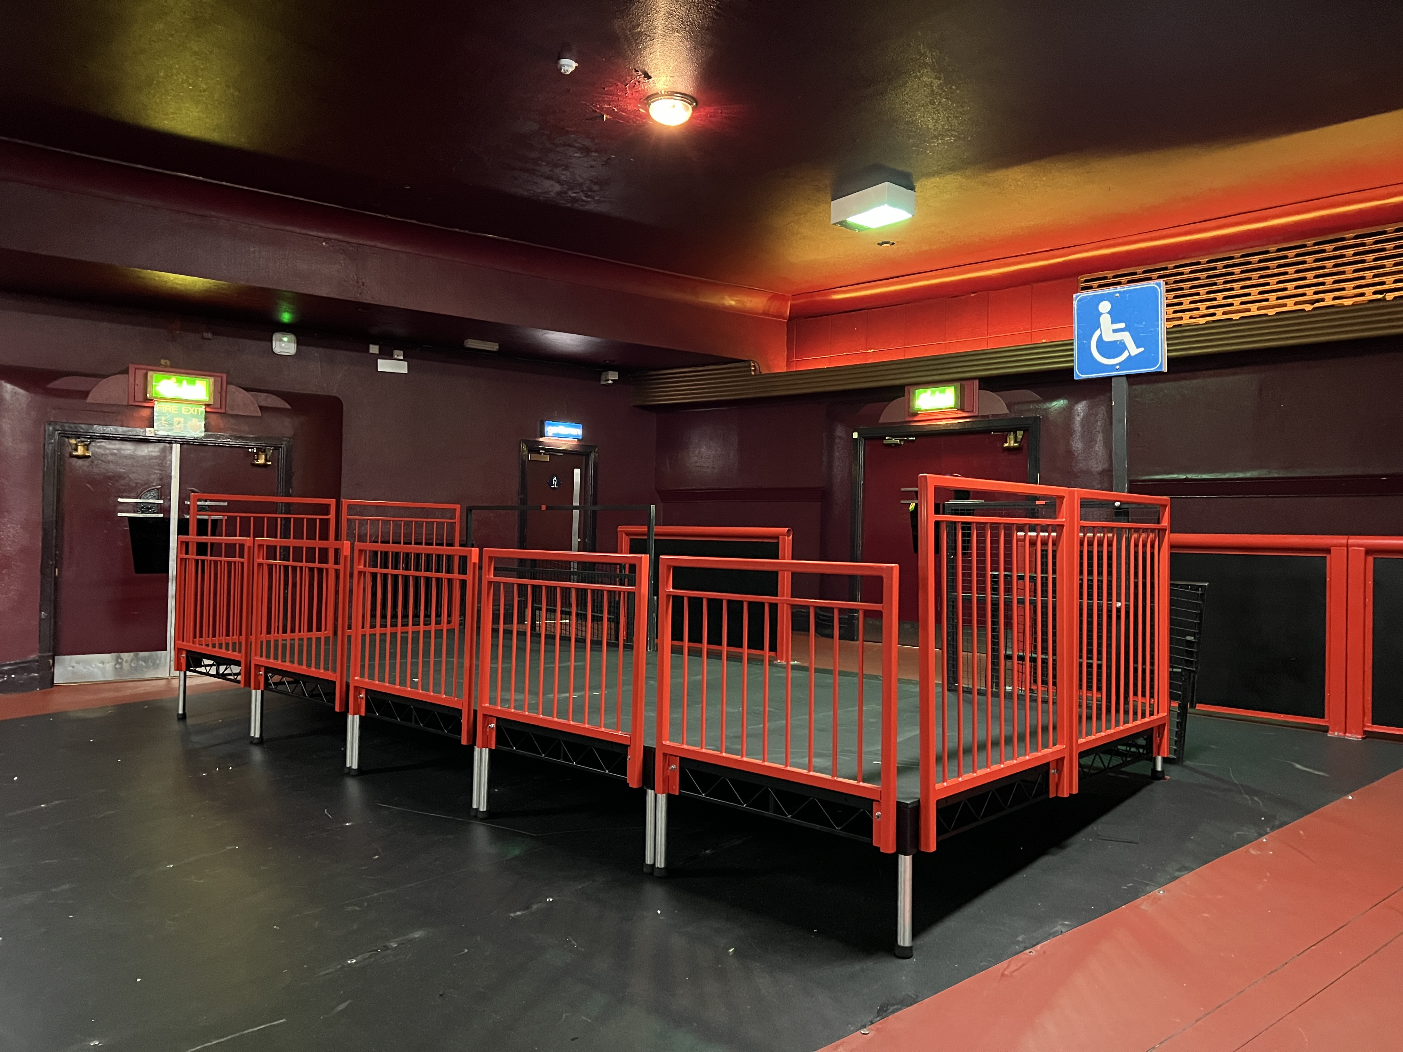
This photo shows our raised access platform, located at the house right rear stalls, it has red barriers and is located next to the access entrance.
View from the platform:
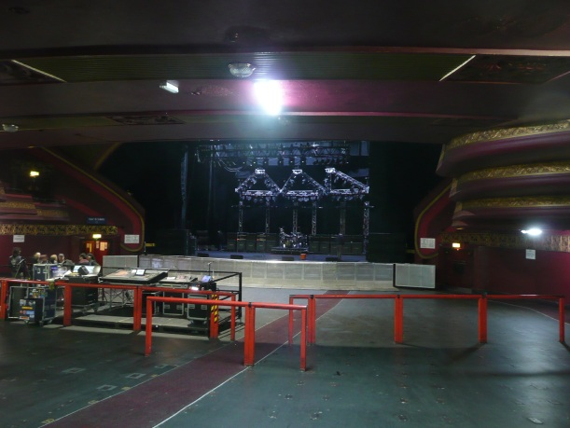
This photo shows a clear, unobstructed view of the stage from the access platform, there are some red barriers which show the middle section of the floor. You can also see the sound desk.
Stalls Access Seating Areas (Available on Fully Seated Shows only)
For fully seated shows, there is no platform in use. Instead, we have designated access seating areas for:
o Wheelchair users: Row C
o Ambulant access customers & PAs: Row D (behind Row C).
Access seating is provided on both house left and house right sides of the stalls.

Stalls Accessible seating:
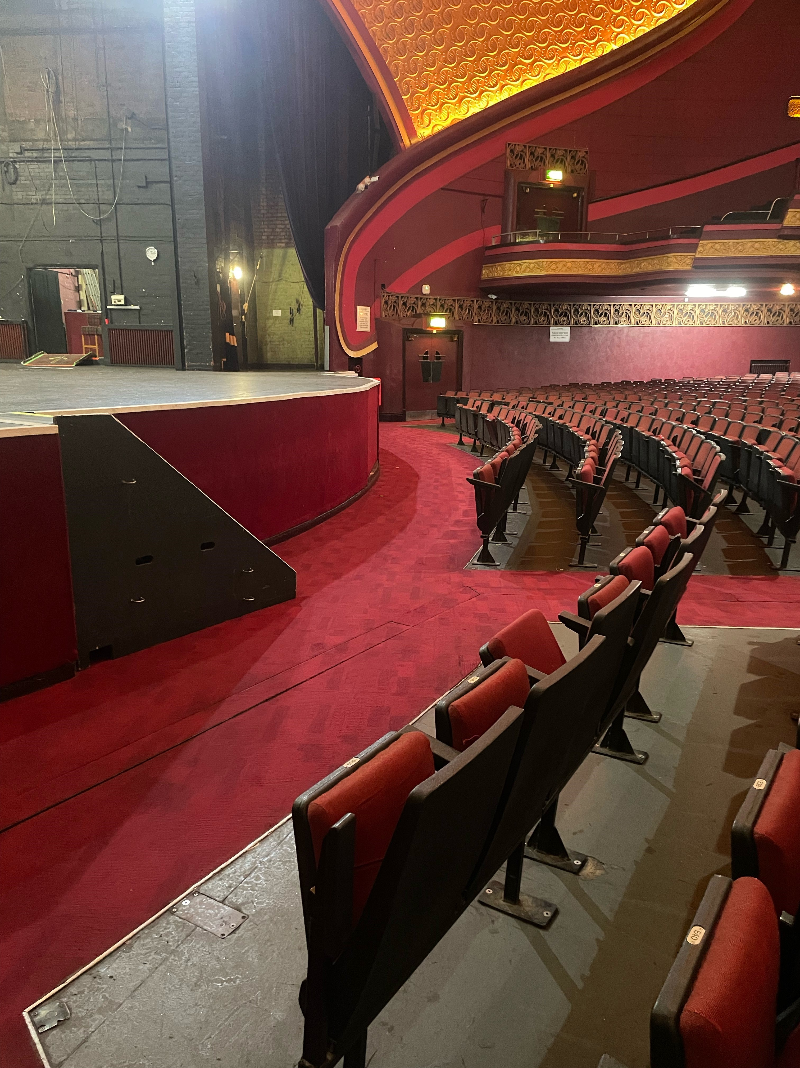
This photo shows the access seating area house left, there are 6 seats, with 6 spaces in front.
View from the Stalls seating:
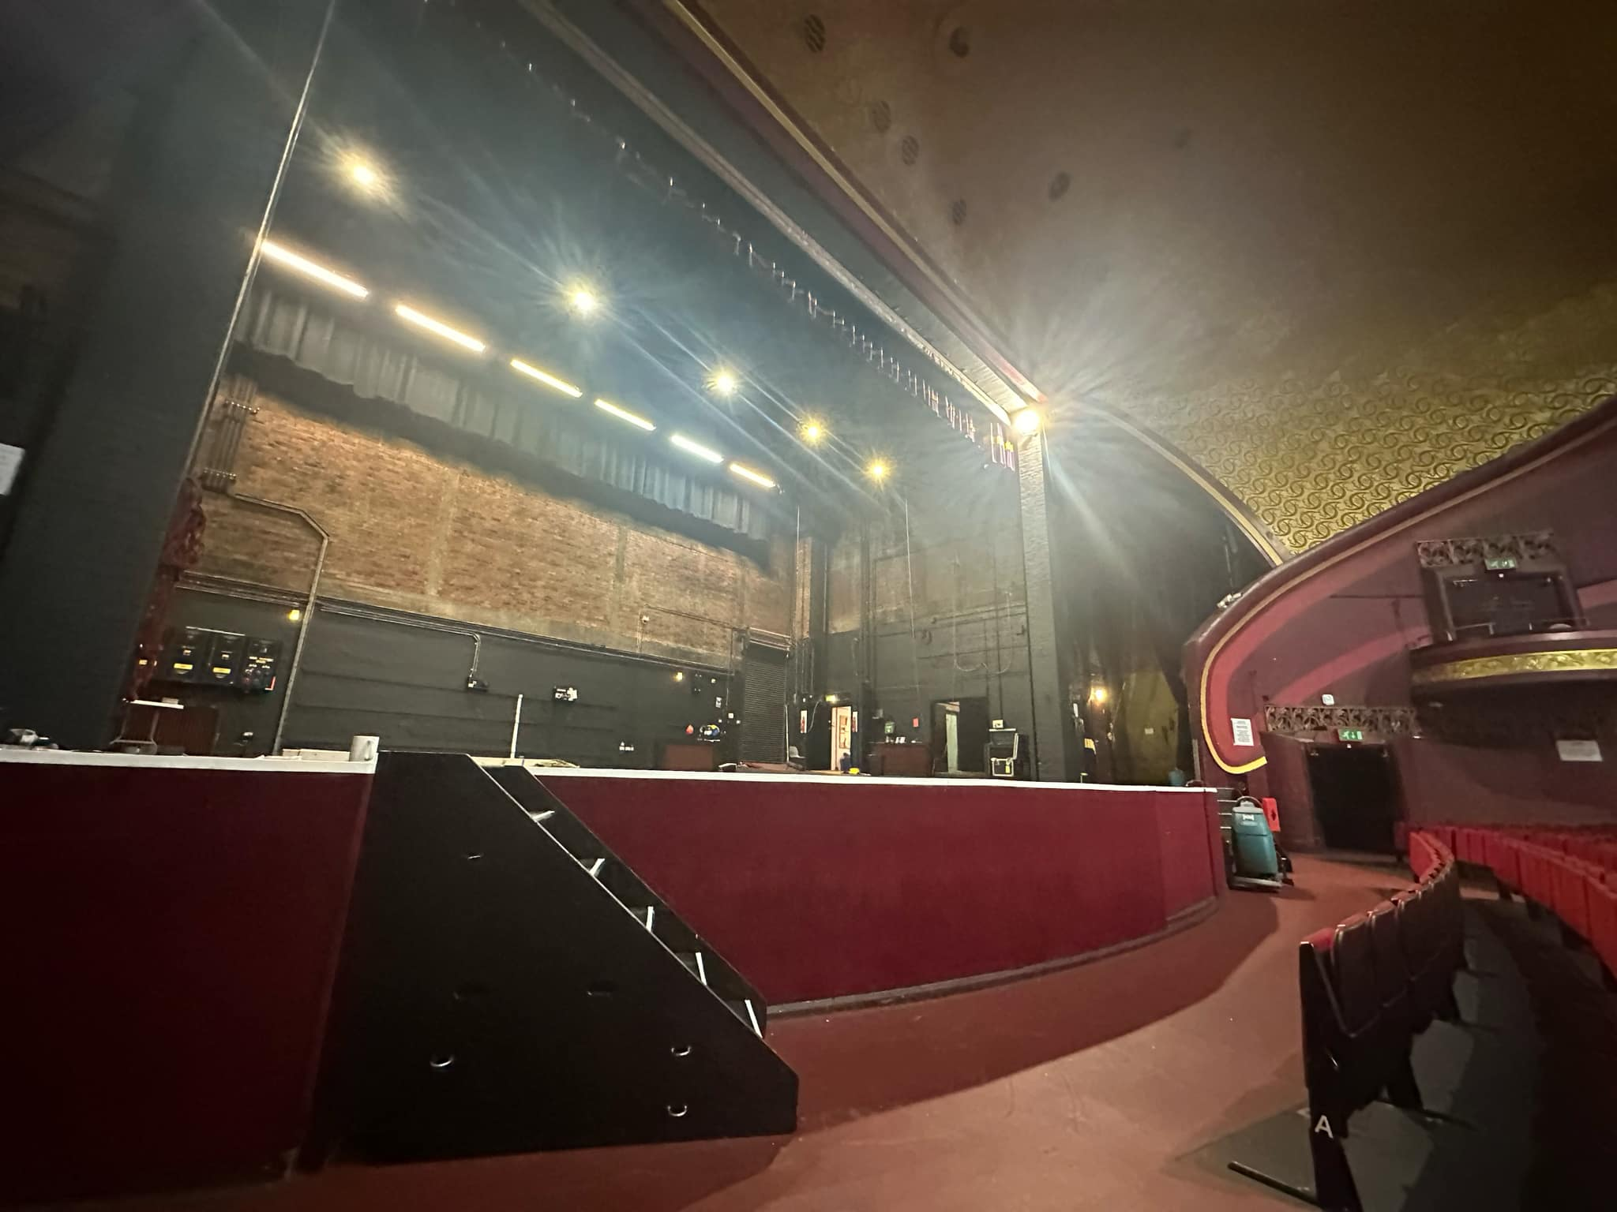
This photo shows a clear, unobstructed view of the stage from the house left access seating area.
Circle Access Seating Area (Available for All Show Types)
For customers who:
  - Can’t stand for long periods
  - Need extra legroom or front-row seating
Please note the venue does not have a lift so this area is only suitable for access customers who are able to use the stairs in the venue, there is approximately 40 steps to reach this area.
Circle Accessible seating:
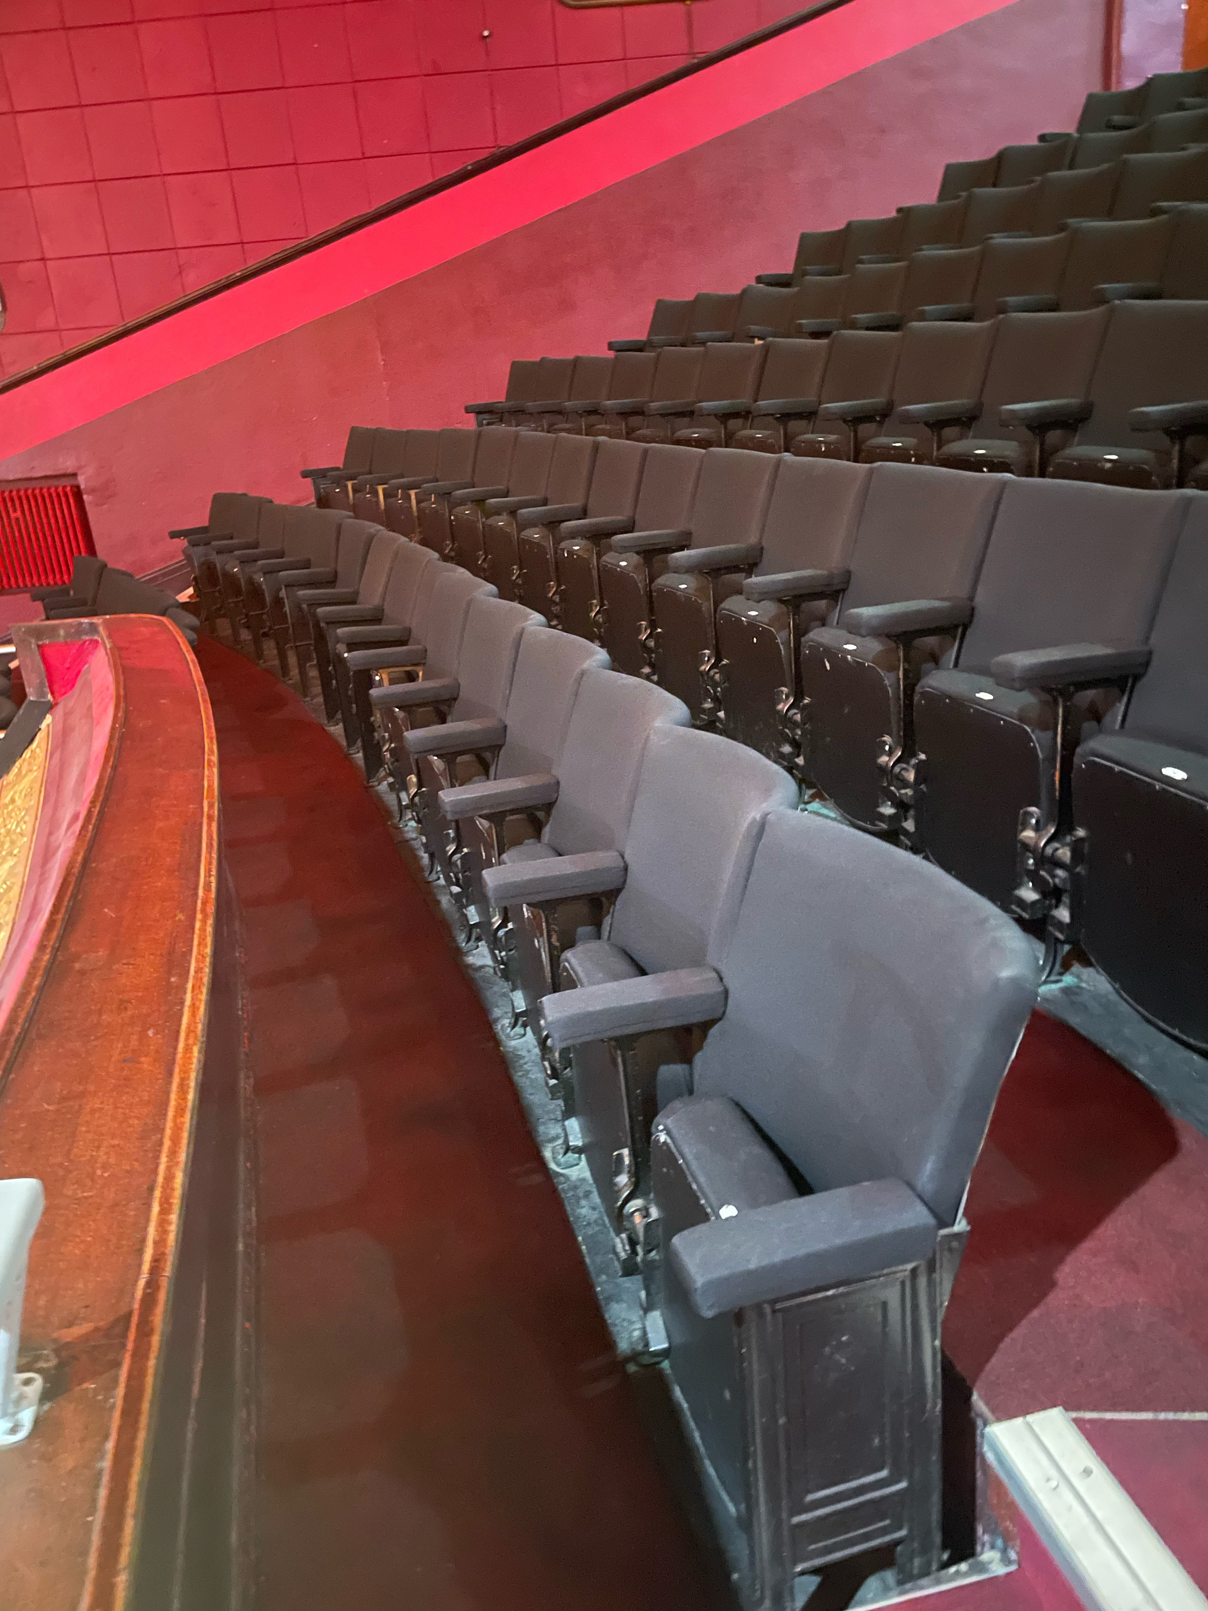
This photo shows the access seating area in the circle.
View from Circle Accessible seats:
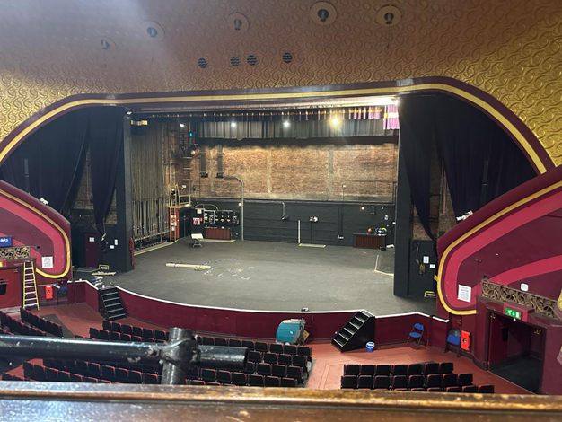
This photo shows a clear, unobstructed view of the stage from the circle access seating area.
Accessible Toilet
We have one unisex accessible toilet in the Rear Stalls (House Left). It is step-free and kept locked. Ask the member of security stood outside for access to this, they have a radar key. There are ambulant accessible toilets in each toilet blocks in the circle.
Hearing Loop
There are no permanent hearing loops in the main auditorium, but they are available upon request at least 31 days prior to the show. There is a permanent hearing loop available in the Box Office.
Performance Interpretation
Please get in touch if you require performance interpretation such as BSL or a hearing loop. So, you know, we'll need 31 days' notice prior to the show to make arrangements.
Assistance Dogs
We welcome assistance dogs in our venue. Please let us know in advance. We can look after your dog in a quiet office for the evening or you are welcome to keep them with you if required.
Strobe Lighting
Most shows include strobe or bright lighting. Signs will be up if there’s a lot of strobes in use. Contact us if you have concerns.
Medical Services
RMS (Remote Medical Services) medical staff are present at all events. They can be found in the First Aid Room or just speak to any staff member for help, and we will contact them for you. You’re welcome to bring medicine, food, drink, or equipment to manage a medical condition. Please let us know ahead of time if you can, on 0161 273 7785.
Smoking Area
If you need to smoke, staff can help you exit and return to the venue during the event. Please just let us know and we can help arrange this for you.
Personal Emergency Evacuation Plans (PEEPs)
We are committed to ensuring the safety of all our visitors, including those who may require assistance in the event of an emergency evacuation.
A Personal Emergency Evacuation Plan (PEEP) is a tailored plan designed to support individuals who may need help leaving the venue safely during an emergency, such as people with mobility, sensory, or cognitive impairments.
If you or someone in your group requires a PEEP, we encourage you to contact us in advance of your visit. This allows our team to understand your specific needs and prepare the appropriate support, including identifying safe evacuation routes and assigning trained staff to assist if required.
To arrange a PEEP or discuss your needs, please contact us via email on access@o2apollomanchester.co.uk or via phone on 0161 273 7785 (Monday to Friday 12PM-4PM, extended during on-sales.)
All information shared will be treated with sensitivity and in accordance with our privacy policy.
Exiting the Venue
When the show finishes, we recommend that you wait a little while before leaving.
This will help you avoid the busy crowds.
Our staff are on hand to help you leave our venue in the safest manner possible.
Please ask us if you need any help with directions, calling a taxi or any general assistance with leaving the venue.
Feedback
We value all feedback at the venue as it helps to continuously improve the experience we offer to all our guests. Following on from your visit we would be grateful for you to leave your feedback here.

