

Live Access at the O2 Academy Leeds

The O2 Academy Leeds welcomes customers with access requirements. We work alongside Attitude is Everything to continuously improve our access provisions.
*Alternative formats of the Live Access document are available on request.
Booking Accessible Tickets
As the O2 Academy Leeds has reserved balcony seating, all accessible bookings are made directly by the access team via email, prior to purchasing tickets. Unfortunately, we may be unable to amend bookings for tickets purchased elsewhere.
Proof of disability is required when booking for the first time. This can be kept on file for future bookings if you complete the access booking form. Our full Essential Companion Policy is here.
Email: access@o2academyleeds.co.uk
Tell us what you need and whether you’d prefer a phone call or email. We aim to reply within 5 working days.
(Note: Emails received before tickets go on sale will not be used to allocate tickets.)
Phone: 0113 385 1555
(Available Monday to Friday, 12pm - 4pm.)
If you are requesting access tickets when an event goes on presale/ general sale, please note we will accept access booking requests on a first-come, first-served basis from the time of the sale (for example from 10am). Any emails received before the on-sale time will not be taken into consideration until after we process the emails that come in from the on-sale time.
Access in and Around our Venue
Priority entry is available with level access through the accessible entrance. Once doors open (usually 7.00pm – check this closer to the time on your tickets or confirmation email). Let security at the main entrance know if you need this. The Stalls area has level access. The Balcony area has 43 stairs and a lift.
What3Words for the entrance: ///slide.oiled.useful

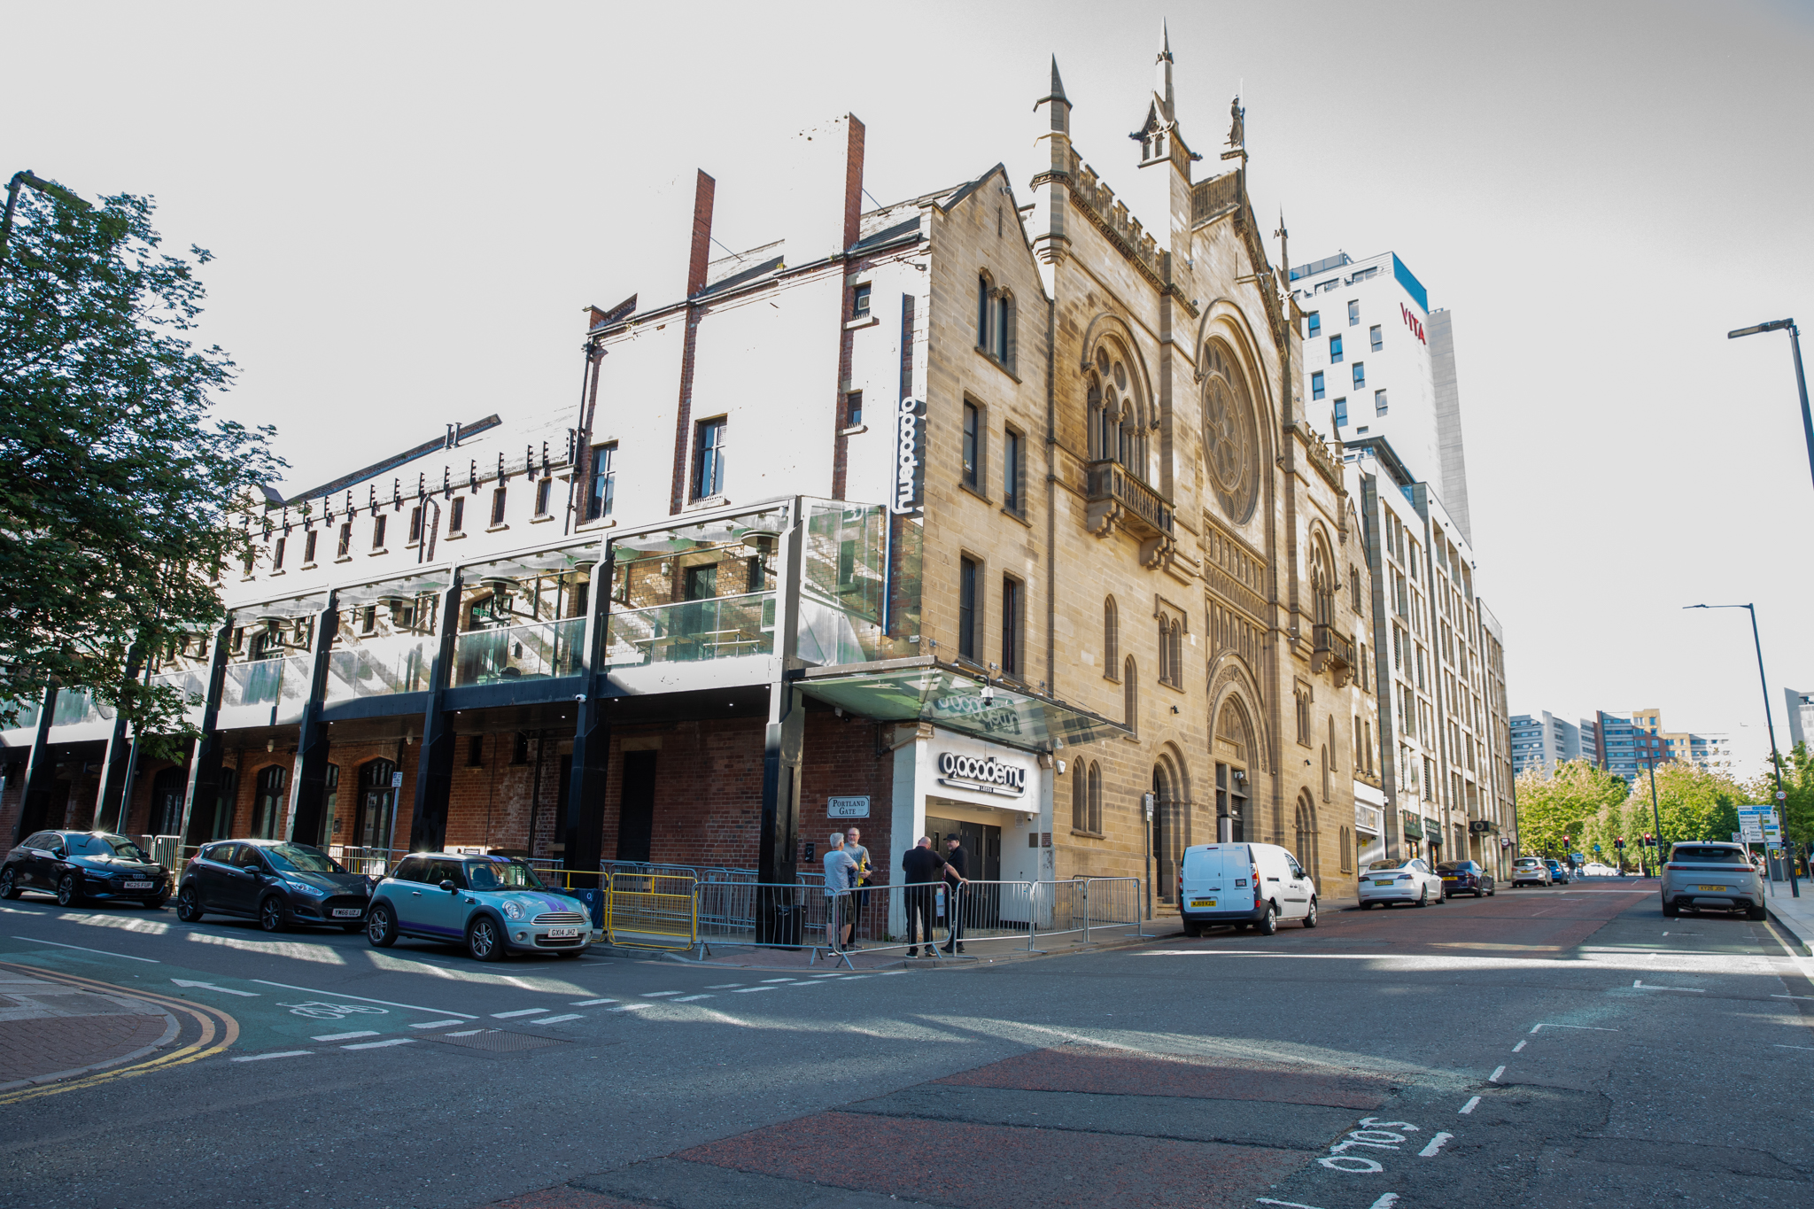

The picture shows the accessible entrance which has level access and a drop curb from the road.
Arrival & Check-In
If you purchased your ticket directly from Ticketmaster (or another ticketing agent) you will have your digital barcodes in the app or email. The email comes from Ticketmaster with the subject as “You’re In! Your [Show Name] ticket confirmation”. We encourage you to download the app and have them added to your mobile’s digital wallet for smooth entry to the venue.
If you purchased your ticket directly from the venue, a member of the access team will have your ticket at the venue ready for the check-in process.
Once you are scanned in, the Access Liaison will show you to your designated area and tell you about our facilities and venue.
Parking and Travel
There are two blue badge parking bays right outside the box office, both of which have a parking duration of four hours, so please plan your travel and journey accordingly. There are also parking spaces in the Woodhouse Lane car park, which is open 24 hours, the Rose Bowl car park and Q-Park The Light which has 24 bays, lift services and automatic doors. Visithttps://www.visitleeds.co.uk/wp-content/uploads/2025/03/D8_Access-Leeds_WEB.pdf for more details and to access their journey planner.
Personal Assistant (PA) Tickets
Personal Assistant tickets are available with valid proof (such as PIP, DLA or the Nimbus Access Card with the +1 present on the card, for other proofs of eligibility, please see our Companion Policy), subject to availability on a 1:1 basis. Accessible and PA tickets should be booked together directly only with the venue by emailing access@o2academyleeds.co.uk..
Our allocation for companion tickets is accounted for within our capacity and are issued on a first-come first-served basis from when an event goes on sale. If an event is sold out, we are unable to appoint companion tickets.
Our full Essential Companion Policy can be found here.
Box Office
The Box Office is at the front of the building. There is one low step, but there’s a buzzer to speak to staff directly. The Box Office is staffed on event nights from the time doors open for the event until roughly 9:30pm. Security Staff are also available outside the box office.
Stalls
Our Stalls section is completely Unreserved Standing and does not have a raised platform or seats. There is an accessible toilet located on this level that can be accessed step-free and a bar that has a lower counter which the access team can show you.
Balcony Access Seating Area
For customers who:
  - Can’t stand for long periods
Balcony Accessible seating:
The picture shows the row of 12 seats offered to access customers who require seating.
Please note these are fixed seats which offer limited legroom. If you require extra legroom, please let us know during the booking process.
Accessible Toilets
We have one accessible toilet in the Stalls section. It has step-free access, and the door is kept locked. If you do not have a radar key, ask the member of medic team in the medic office located next to the toilet for access to this, they have a radar key. If they are not in the office, please ask a member of security or bar staff to contact the access team to unlock this.
There is an accessible toilet for the balcony section located on a mezzanine level. There is one staircase or the use of the lift to access it.
Both toilets have stoma shelves.
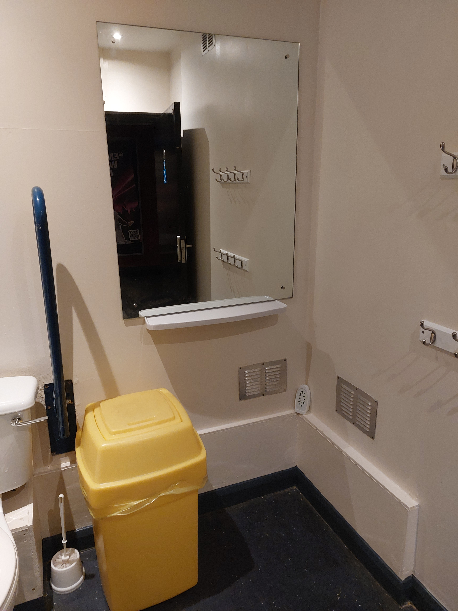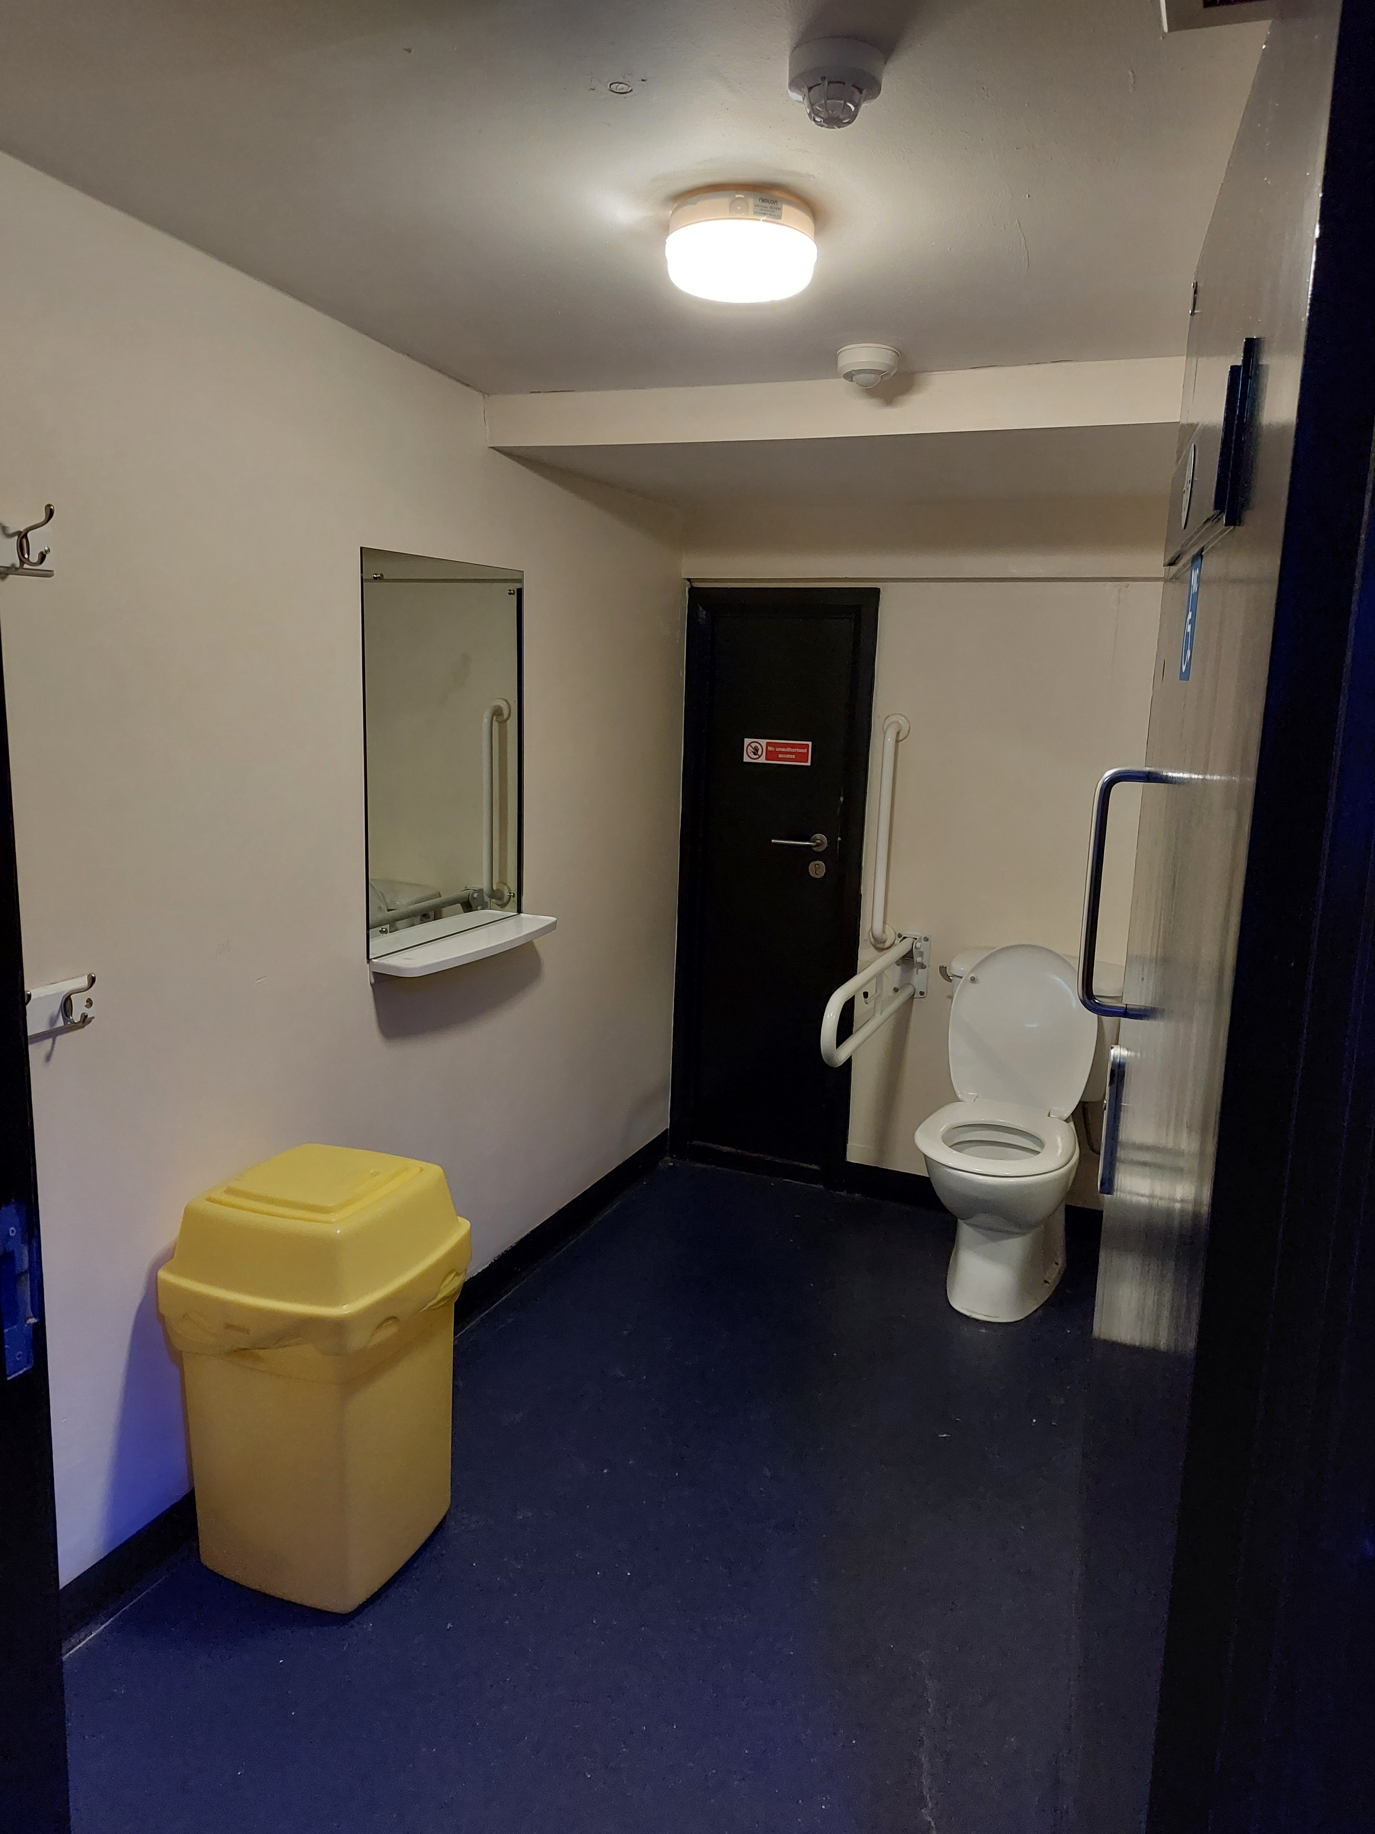

Merchandise
For some shows a merch stand will be set up on the balcony however, generally the merchandise will only be available in the stalls section.
A member of the merch team can come to the balcony with an iPad to show balcony access customers what merch is available and can take payment for items. This will then be brought up to the customer or available to collect when leaving the event.
Balcony customers can also go to the merchandise stand in the stalls section after the event.
Bars
There are four bars in the stalls section and one of which has a lowered counter.
There are two bars on the balcony. One of which has step-free access, and one is at the top on a staircase.
We can arrange for a member of bar staff to come to the access area to take drink orders and payments.
Hearing Loop
There is a hearing loop at the box office.
Performance Interpretation
Please get in touch if you require performance interpretation such as BSL or a hearing loop. So, you know, we'll need at least 31 days' notice prior to the show to make arrangements.
Assistance Dogs
We welcome assistance dogs in our venue. Please let us know in advance. We can look after your dog in a quiet office for the evening or you are welcome to keep them with you if required.
Strobe Lighting
Most shows include strobe or bright lighting. Signs will be up if there’s a lot of strobes in use. Contact us if you have concerns.
Medical Services
Medical staff are present at all events. They can be found in the First Aid Room or just speak to any staff member for help, and we will contact them for you. You’re welcome to bring medicine, food, drink, or equipment to manage a medical condition. Please let us know ahead of time if you can, either by email at access@o2academyleeds.co.uk or by phone on 0113 389 1555.
Smoking Area
If you need to smoke, staff can help you exit and return to the venue during the event. Please just let us know and we can help arrange this for you.
Personal Emergency Evacuation Plans (PEEPs)
We are committed to ensuring the safety of all our visitors, including those who may require assistance in the event of an emergency evacuation.
A Personal Emergency Evacuation Plan (PEEP) is a tailored plan designed to support individuals who may need help leaving the venue safely during an emergency, such as people with mobility, sensory, or cognitive impairments.
If you or someone in your group requires a PEEP, we encourage you to contact us in advance of your visit. This allows our team to understand your specific needs and prepare the appropriate support, including identifying safe evacuation routes and assigning trained staff to assist if required.
To arrange a PEEP or discuss your needs, please contact us via email on access@o2academyleeds.co.uk or via phone on 0113 389 1555 (Monday to Friday 12PM-4PM.)
All information shared will be treated with sensitivity and in accordance with our privacy policy.
Exiting the Venue
When the show finishes, we recommend that you wait a little while before leaving.
This will help you avoid the busy crowds.
Our staff are on hand to help you leave our venue in the safest manner possible.
Please ask us if you need any help with directions, calling a taxi or any general assistance with leaving the venue.
Feedback
We value all feedback at the venue as it helps to continuously improve the experience we offer to all our guests. Following on from your visit we would be grateful for you to leave your feedback here.

