O2 FORUM KENTISH TOWN LIVE ACCESS GUIDE

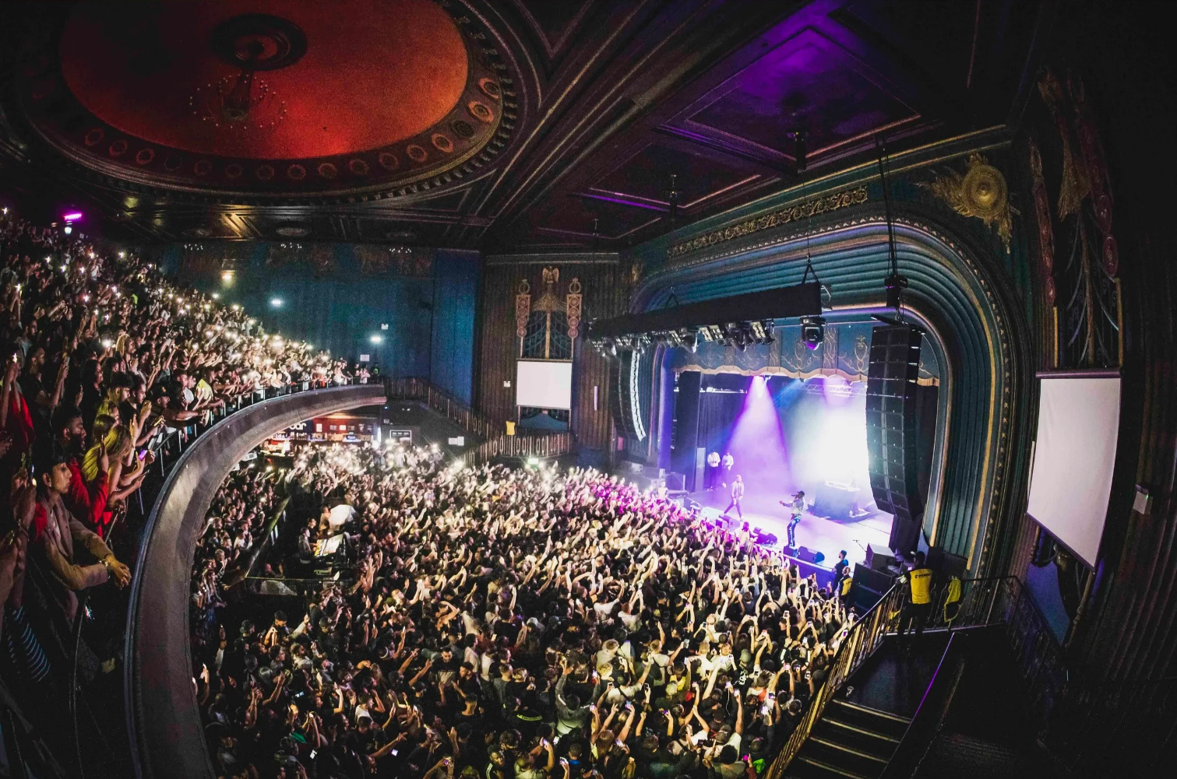

The O2 Forum Kentish Town works alongside Attitude is Everything to continuously improve our access provisions.

*Alternative formats of the Live Access Guide are available on request including easy-read and audio.
Contents Page
Contact Us 3
Booking Tickets 3
Companion Tickets 3
Viewing Platforms & Wheelchair Spaces 3
Accepted Proof of Eligibility 4
Access Booking Form 4
Getting Here 5
Drop-off Point 5
Arrival & Check-in 5
Box Office 5
Hearing Loop 5
Toilets 5
Blind or Vision Impaired Visitors 5
Performance Interpretation 5
Assistance Dogs 6
Bar Service 6
Cloakroom 6
Medical Room & Emergencies 6
Customer with Medical Emergencies 6
Merchandise 6
Strobe Lighting & Special Effects 6
Map of Venue and Accessible Areas 7
Contact Us
Telephone: 020 3545 5900
Available between the hours of 11:00 – 17:00 Monday – Friday

Email: access@o2forumkentishtown.co.uk
Monitored during work hours Monday – Friday. Please allow up to 10 days for a response

Website: www.academymusicgroup.com/o2forumkentishtown/accessibility

Post: Box Office
O2 Forum Kentish Town
9-17 Highgate Rd
London
NW5 1JY

Booking Tickets
Due to limited accessible spaces at the O2 Forum Kentish Town, please get in touch with us via telephone or email before purchasing your tickets. A member of our access team will review your application within 10 days and get back to you with next steps to finalise your booking.

Proof of Eligibility is required when booking for the first time. This can be kept on file for future bookings if you select this option on the access booking form. Please see next page for accepted forms of Proof at our venue

Companion Tickets
If you require a ticket for a companion or personal assistant, please let us know when you book. We offer one companion ticket, free of charge, to provide support you need and additional assistance in the event of an emergency evacuation. Our full Essential Companion Policy can be found here.

Viewing Platforms & Wheelchair Spaces
Wheelchair spaces are available when you book, but are limited on a first-come, first-served basis. The Stalls Access Area is located at the front of the higher tier on the main floor, approximately halfway back in the auditorium with step free access available.

We understand that you want to be with your friends, but due to space limitations, we may only be able to allow you and your companion into an accessible area and cannot always guarantee seated options.
Accepted Proof of Eligibility
The Access Card – If you are an Access Card holder you will only need to provide your full name and card ID number. For more information on the Access card and details of how to obtain one please follow this link http://www.accesscard.org.uk/apply/. The Access Card informs providers quickly and discreetly about the support and facilities a person may require when attending the venue. This is provided by Nimbus Disability. Please note, if you carry a valid Nimbus Access Card, the Access Booking Form is not required for booking.

Non Access Card Holders – DLA (Disability Living Allowance)/ PIP (Personal Independence Payments) letter or equivalent/ Recognised assistance dog card/ Evidence that a person is registered with severe sight impairments/ Letter from a medical professional (consultant letter, doctors letter etc. providing they outline the persons disability). Christmas bonus letters and blue badges are not accepted as evidence.
Please note with PIP evidence you must show all pages regarding ratings/scores or the awards page that shows when the PIP is valid until, i.e you are awarded the standard rate from date until date/ongoing. PIP yearly April updates do not have the information above on them therefore we are unable to accept them.

Access Booking Form
The Access Booking Form can be found on our website as a downloadable Word Document, or follow this link to download – Forum Access Booking Form

Please complete all relevant sections and return to the Access Team. You can do this via email at access@o2forumkentishtown.co.uk or you can post the form along with a copy of a person’s evidence of disability to the following address:

Box Office
O2 Forum Kentish Town
9-17 Highgate Rd
London
NW5 1JY

Any sensitive information such as address, date of birth, or amounts can be blanked out. All copies of evidence received will be securely destroyed once requirements have been obtained. The venue booking form has an option to be added to our internal database. If selected, no further evidence will need to be provided on future bookings within a 3 year period.

Getting Here
Just visit Getting here for all travel details and accessible options for getting to us.

Drop-off Point
We are on a busy main road, so if you need to do a drop off, please be careful and use the adjacent street, Greenwood Place.

Arrival & Check-In
If you need assistance, let us know in advance and someone will meet you at the front doors of O2 Forum Kentish Town, just ask a member of our front of house staff to show you the way. We recommend arriving about 15 minutes before doors open, just to make things easier.

With any other access requirements, please let us know in advance and if you require a seat, our staff will assist. We do not have a lift to upper levels, so if you are unable to use the stairs, please get in touch.

Box Office
Our box office doesn’t have a lowered counter, so we ask that you speak to our staff upon arrival will happily assist you. All ticket orders will be processed in advance and advised prior to the show, so please bring all your booking information with you.

Hearing Loop
There is a permanent hearing loop available in the Box Office. Unfortunately, there are no permanent hearing loops in the main auditorium.

Toilets
On ground level, there’s an accessible toilet controlled by a RADAR key that staff will provide access to if needed. Other toilets are available in the same area and upper level of the theatre if you are seated here.

Blind or Visions Impaired Visitors
If you require braille or large print material, please let us know in advance by contacting us via email, or call +44 (0)203 545 5900.

Performance Interpretation
Just get in touch with us if you require a BSL interpreter. So you know, we'll need 31 days' (one month) notice prior to the show to make arrangements.
Assistance Dogs
Assistance dogs are welcome*, just be sure to let us know when you book.
We can discuss suitable locations where your dog can stay throughout the show. Alternatively, if you would like your dog to be looked after, we'll arrange for someone to meet you at the entrance and guide you to your seat. Dogs will be looked after throughout the event in a quiet location with somewhere to lay, with a bowl of water.
*We recommend bringing hearing protection for your dog.

Bar Service
There aren’t any lowered areas at our bars, unfortunately, but there is a bar in the stalls that’s very close to the accessible platform and our bar staff will be happy to assist you. Bars on the upper level are just outside and at the rear of the auditorium and our staff will be happy to help you with any service you may need.

Cloakroom
Please let any staff members know if you need assistance for our cloakroom facilities when you arrive and they can help you in both stalls and upper level.

Medical Room & Emergencies
We have a medics room and there's a medic present at most events, if you require any assistance or a private area at any point, please just speak to a member of our staff. Any particular requirements can of course be asked in advance. Just get in touch.

Customers with Medical Requirements
Should you need to bring food or drink to manage a medical condition, or bring medicines or medical equipment with you, just get in touch.

Merchandise
If there is merchandise for sale, it is usually found in the auditorium at the rear of stalls, so please ask our staff if you need any assistance.

Strobe Lighting & Special Effects
Most shows and events now use strobe lighting and smoke effects, but we’ll make sure there are signs up to let you know and you can also ask when you arrive. If this is an issue, please do let one of our team know, before or during an event.

