

Live Access at the O2 Academy Brixton
The O2 Academy Brixton welcomes customers with access requirements. We work alongside Attitude is Everything to continuously improve our access provisions.
*Alternative formats of the Live Access document are available on request.
Booking Accessible Tickets
Please book your tickets directly with Ticketmaster if you require either a wheelchair or ambulant accessible platform ticket, or an ambulant accessible circle ticket. You can visit our full event listings and ticket availability here.
Please make sure you purchase our designated Accessible Tickets, available on each event listing. Should you need any further information, please get in touch on the phone from 11am - 3pm, Monday to Friday on +44 (0)20 7787 3129 or email our Access team for further support. We'll do our best to respond as quickly as we can.
Companion Tickets
We offer one companion ticket, free of charge to provide the support needed and additional assistance during the course of an emergency evacuation and so you know, proof of eligibility will be required.
Our full Essential Companion Policy can be found here.
Stalls and accessible platform
Please purchase tickets directly with Ticketmaster for the stalls standing area, or wheelchair accessible platform and if you require a companion ticket, please do book this alongside yours when you place your order.
Circle seated (balcony)
If you are purchasing tickets for the circle seated area and if you require a companion ticket, please do book this alongside yours when you place your order with Ticketmaster, by selecting two of our designated accessible ambulant seats in Block 6 or Block 8 . These tickets will be marked as either full price or free essential companion and must be bought together. Companion tickets must be booked at the time of purchase please.
Please be aware there are up to 50 (approx) steps to the circle. Please note we do not have lift access or an accessible toilet at this level. For more information and guidance, please do not hesitate to get in touch by email or call +44 (0)20 7787 3129.
Box office and accessible entrance
Our box office doesn’t have a lowered counter, so we ask that you speak to our staff upon arrival and they will happily assist you. All ticket orders are processed in advance and advised prior to your event.
Getting Here
Just visit Getting here for all travel details and accessible options for getting to us.
Drop-off Point
Drop-off and collection points are available for visitors as required.
Wheelchair Spaces
These are available when you book, but they’re limited on a first come, first served basis.
Accessible Viewing Area
We understand that you want to be with your friends, but due to space limitations, we may only be able to allow you and your companion into an accessible area and cannot always guarantee seated options.
Blind or Vision Impaired Visitors
If you need braille or large print material, please let us know in advance by contacting us via email, or call +44 (0)20 7787 3129.
Guide and Assistance Dogs
Guide and hearing assistance dogs are welcome*, just be sure to let us know when you book.
We can discuss suitable locations where your dog can stay throughout the show. Alternatively, if you would like your dog to be looked after, we'll arrange for someone to meet you at the entrance and guide you to your seat. Dogs will be looked after throughout the event in a quiet location with somewhere to lay, with a bowl of water.
*We recommend bringing hearing protection for your dog.

On Arrival
If you need assistance or ramp access, let us know in advance and someone will meet you at the front of the venue. We’d recommend arriving about 15 minutes before doors open, just to make things easier.
We have a ramp to the left-hand side of the main doors, which also leads to the box office. It’s quite steep, but front-of-house staff will always be on hand to assist entry and exit. There’s an accessible platform to the left of the stalls area with a good view of the stage.
Auditorium
Wheelchair users will be shown into the auditorium, it’s level access straight into the venue. Any customers who need a seat in the balcony (Dress Circle), note that there's a number of steps and stairs with turns from the foyer to this upper level. Please do let us know in advance if you require assistance or alternative arrangements, and we shall do our best to help you.
Just so you know, e-cigarettes and vapes are not permitted, please see our FAQs for details.
Toilets
On the ground floor, close to the rear bar’s accessible platform, there is an accessible toilet that is Radar Key accessible and staff will always be on hand to provide access if needed. There are additional toilets are available throughout the building, just ask our staff to show you the way if you’re visiting us for the first time.
Bar Service
There aren’t any lowered areas at our bars, unfortunately, but the bars in the auditorium are close to the accessible platform and our bar staff will be happy to assist you.
Cloakroom
Please let any staff members know if you need assistance for our cloakroom facilities when you arrive and they can help you in both stalls and upper levels.
Medical Room and Emergencies
We have a medics room in the foyer at ground level, if you require any assistance or a private area at any point, please just speak to a member of our staff. Any particular requirements can of course be asked in advance. Just get in touch.
Customers with medical requirements
Should you need to bring food or drink to manage a medical condition, or bring medicines or medical equipment with you, just get in touch.
Merchandise
If there is merchandise for sale, you’ll find it in the main foyer near the entrance.
Strobe Lighting and Special Effects
Most shows and events now use strobe lighting and smoke effects, but we’ll make sure there are signs up to let you know and you can also ask when you arrive. If this is an issue, please do let one of our team know, before or during an event.
Access to performance
Just get in touch with us if you require a BSL interpreter. So you know, we'll need 31 days' (one month) notice prior to the show to make arrangements.
Venue map
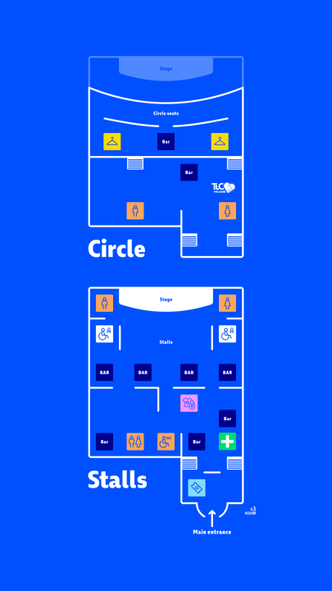
Below is a map of O2 Academy Brixton, with all exits, welfare and cloakrooms highlighted. Click here to download.

