
Live Access at O2 City Hall Newcastle
The O2 City Hall Newcastle welcomes customers with access requirements. We work alongside Attitude is Everything to continuously improve our access provisions.
*Alternative formats of the Live Access document are available on request.
Booking Accessible Tickets
As O2 City Hall Newcastle has some reserved seating, all accessible bookings are made directly with the access team prior to booking. Unfortunately, we are unable to amend bookings made elsewhere.
Proof of disability is required when booking for the first time. This can be kept on file for future bookings if you complete the access booking form. Our full Essential Companion Policy is here.
Email: access@o2cityhallnewcastle.co.uk
We aim to reply within 5 working days.
Phone: 0191 240 6050
(Available Monday to Friday, 12pm - 4pm. Emails are monitored from 10am-4pm)
Access in and Around our Venue
Priority entrance is available via the accessible, level-access entrance. Once doors open (please check door times on our website or your ticket), you may enter through the side entrance with level access, just inform security at the main entrance if you require this. The Stalls area is fully level-accessible. The Balcony is accessed by approximately 40 stairs and does not have lift access.
What3Words for the entrance: fleet.sorry.tennis
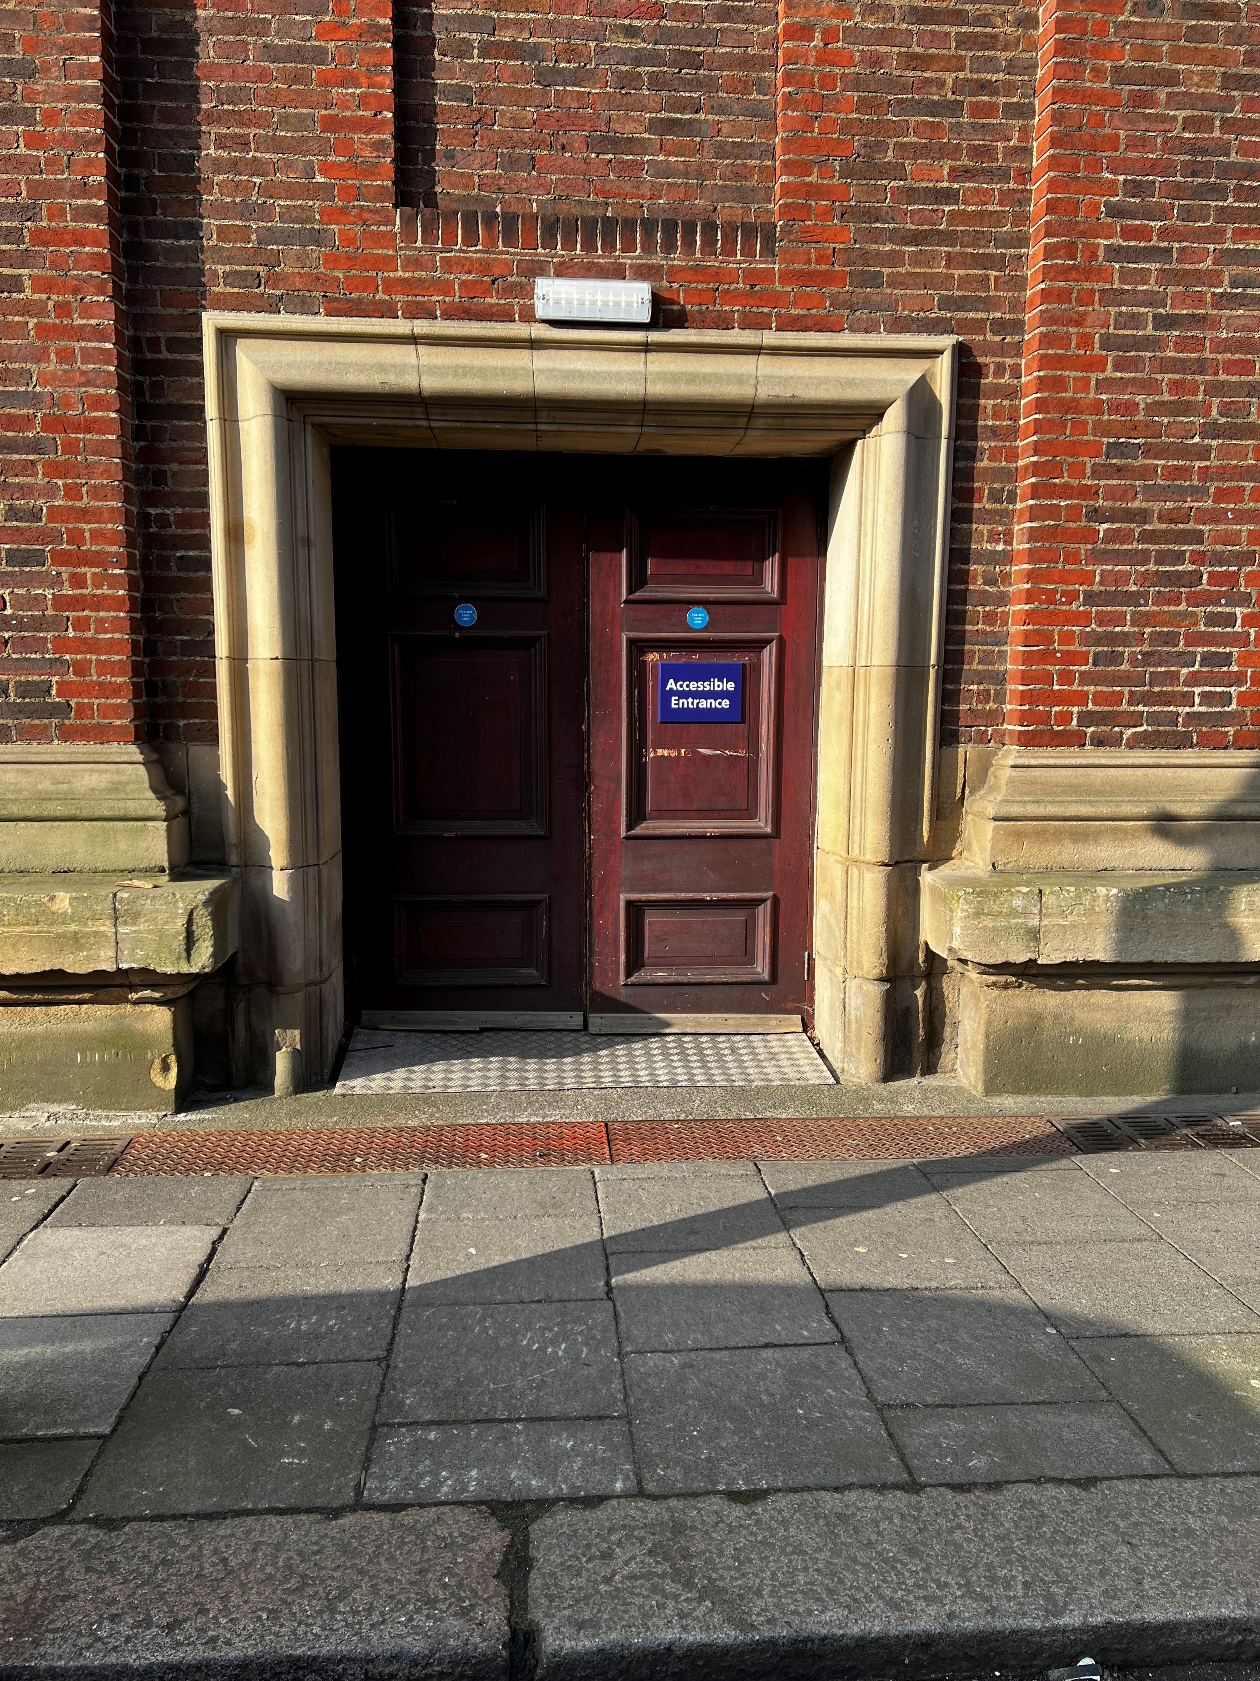
The picture shows an accessible entrance on College Street. It is a brown door with a blue accessible sign.
Arrival & Check-In
You will have paper tickets if you have booked through our access team, so please have these ready to be scanned into the venue. Once you are scanned in, the Access Liaison will show you to your designated area and tell you about our venue.
Parking and Travel
There are five parking spaces for blue badge holders in College Street Car Park and a number of spaces a short distance away on John Dobson Street, close to the NCP Car Park. Most parking meters in the local vicinity are free to blue badge holders.
Our nearest Metro station is at Haymarket, which is around 300 metres away, use the entrance on Northumberland Street. Information for customers with access requirements, as well as all timetables and services, can be found at Nexus.
Eldon Square bus station, around 500 metres away, is mainly served by Go North East. Plan your journey at Go North East.
Haymarket bus station, is also close at around 450 metres away and is mainly served by Go North East and Arriva North East link.
Personal Assistant (PA) Tickets
Personal Assistant tickets are available with valid proof (such as PIP, DLA or the Nimbus Access Card with the +1 present on the card, for other proofs of eligibility, please see our Companion Policy), subject to availability on a 1:1 basis. Accessible and PA tickets should be booked together directly only with the venue by calling 0191 240 6050. We are unable to amend bookings made elsewhere.
Box Office
The Box Office is located at the front of the building and is accessed via five steps from street level. Step-free access is available through the auditorium via the Access Entrance. Please speak to a member of our team if you require level access. The Box Office is staffed on event nights from approximately 5.00pm, and security staff are also present outside the venue.
What3Words location for the Box Office: storm.until.lived
Stalls Access Viewing Platform (Available on Standing Shows only)
There is a raised viewing platform in rear Stalls (House Right). This is available for wheelchair users and customers who are unable to use stairs to reach the balcony. One companion can sit with the access customer, and other members of the party can stand nearby. The Access Liaison and a member of security will always be on duty throughout the show.
Accessible Viewing platform:
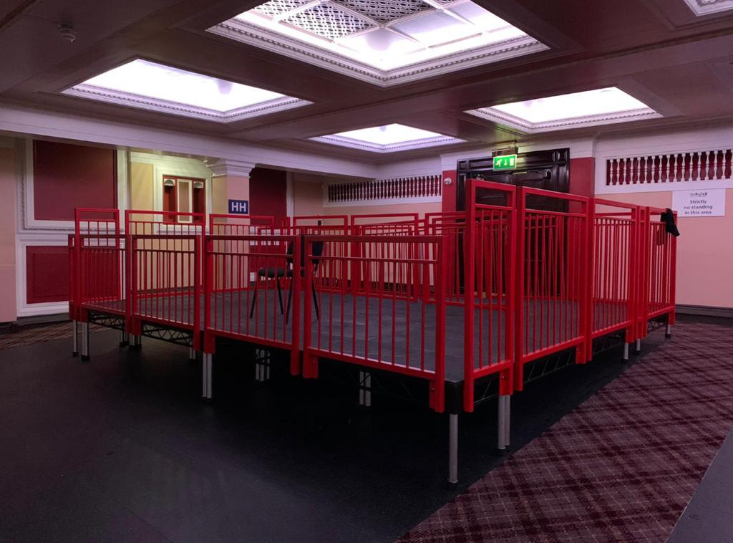
This photo shows our raised access platform, located at the house right rear stalls, it has red barriers and is located next to the access entrance.
View from the platform:
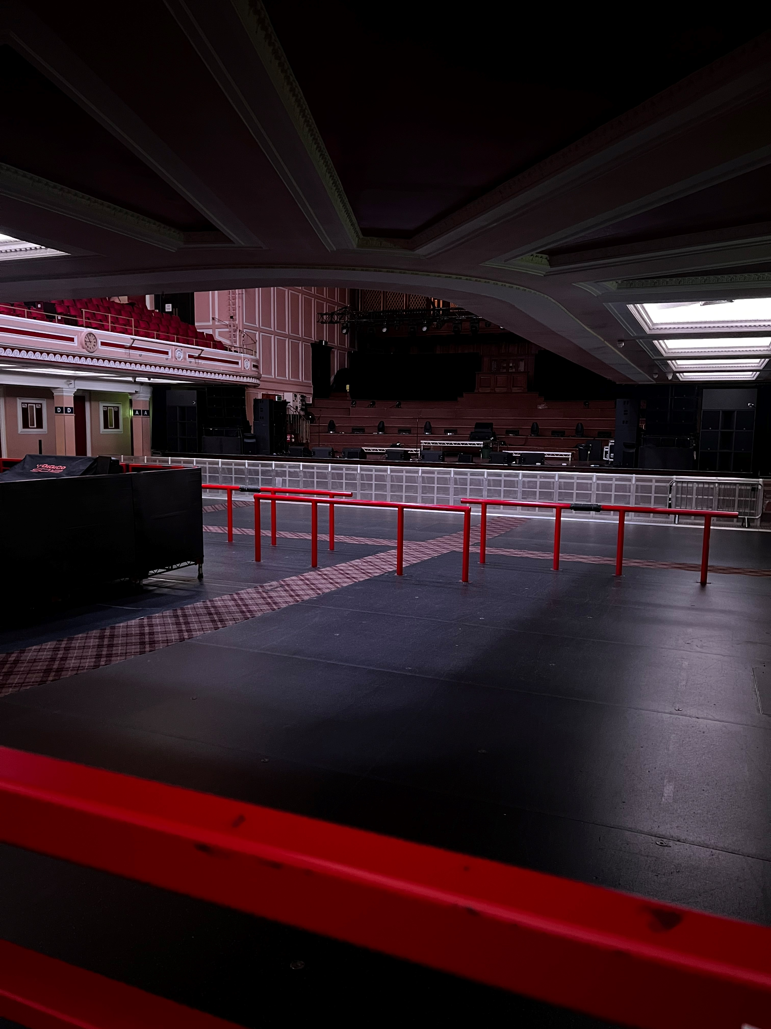
This photo shows a clear, unobstructed view of the stage from the access platform, there are some red barriers which show the middle section of the floor. You can also see the sound desk.
Stalls Access Seating Areas (Available on Fully Seated Shows only)
For fully seated shows, there is no platform in use. Instead, we have designated access seating areas for:
o Wheelchair users: Rows A, B and C located on both house left and house right of the stalls.
Ambulant accessible seating is tailored to each customer’s specific requirements at the time of booking.

Stalls Wheelchair positions:
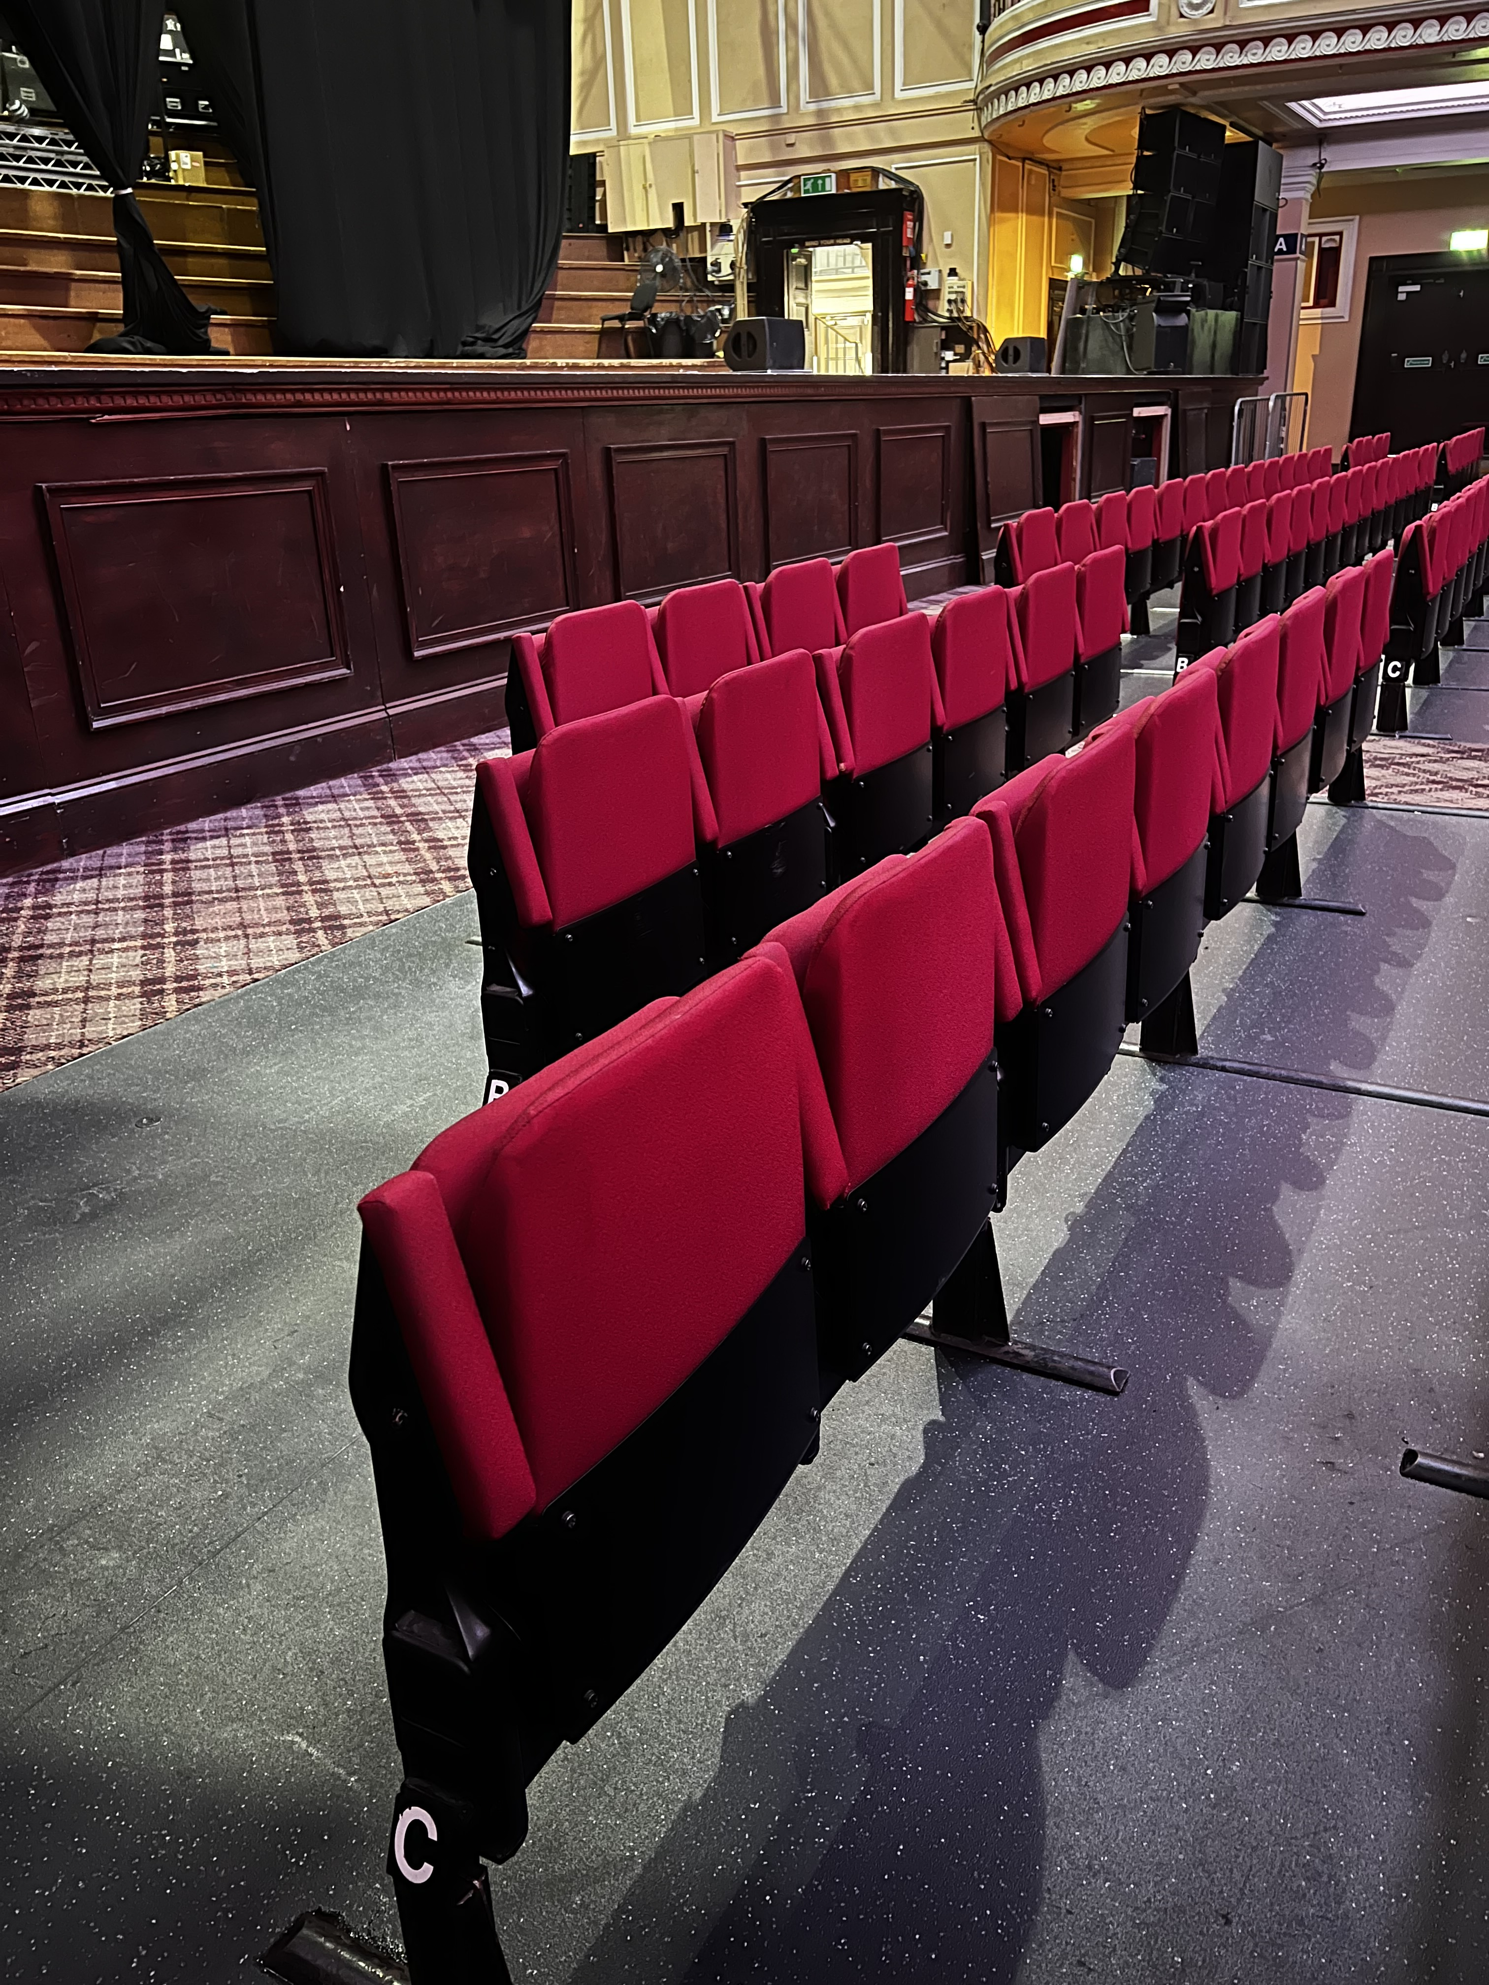
This photo shows the wheelchair seating area on house left. There are three wheelchair spaces with companion seating, and a further three on house right.
View from the Stalls wheelchair seating:
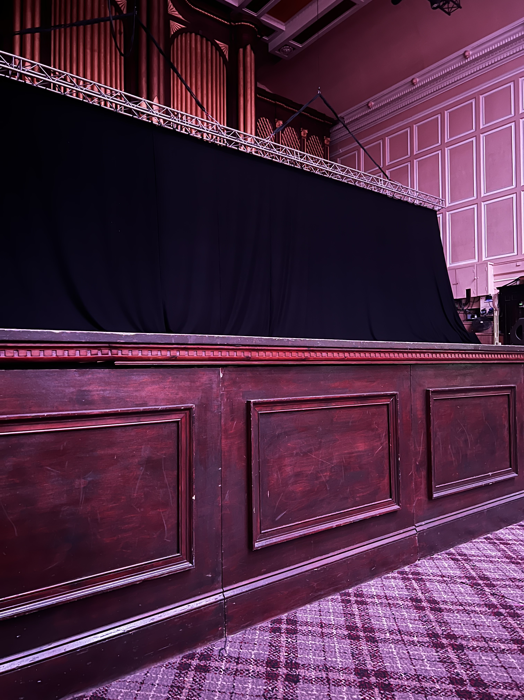
This photo shows a clear view of the stage from the house left access seating area.

Rows with additional legroom (Available on Fully Seated Shows only)
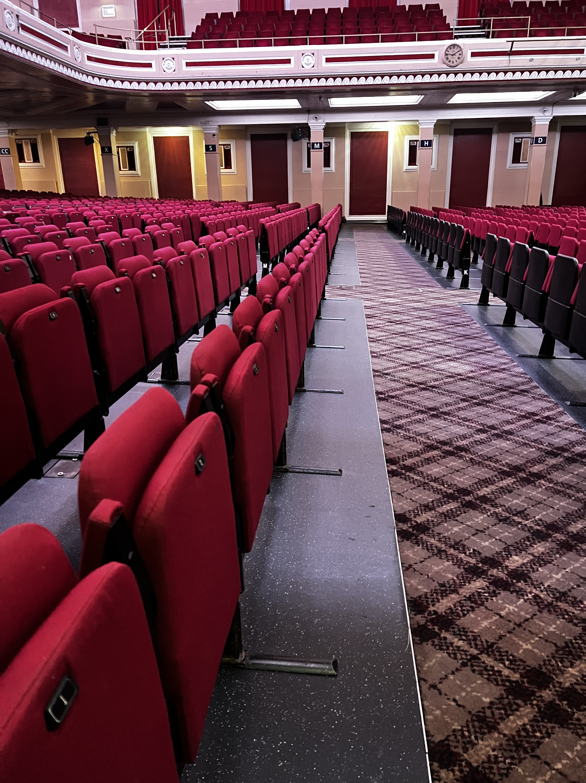
This photo shows one of our Stalls rows with additional legroom: Row L. Additional legroom is also available in Row A. Both offer unobstructed views of the stage.
Balcony Access Seating Area (Available for All Show Types)
For customers who:
  - Can’t stand for long periods
  - May need extra legroom or front-row seating
Please note the venue does not have a lift so this area is only suitable for access customers who are able to use the stairs in the venue, there is approximately 40 steps to reach this area.
Balcony accessible seating is also tailored to each customer’s specific requirements at the time of booking. Please contact us directly if you require any further assistance.

Rows with additional legroom in Balcony (Available for All Show Types)
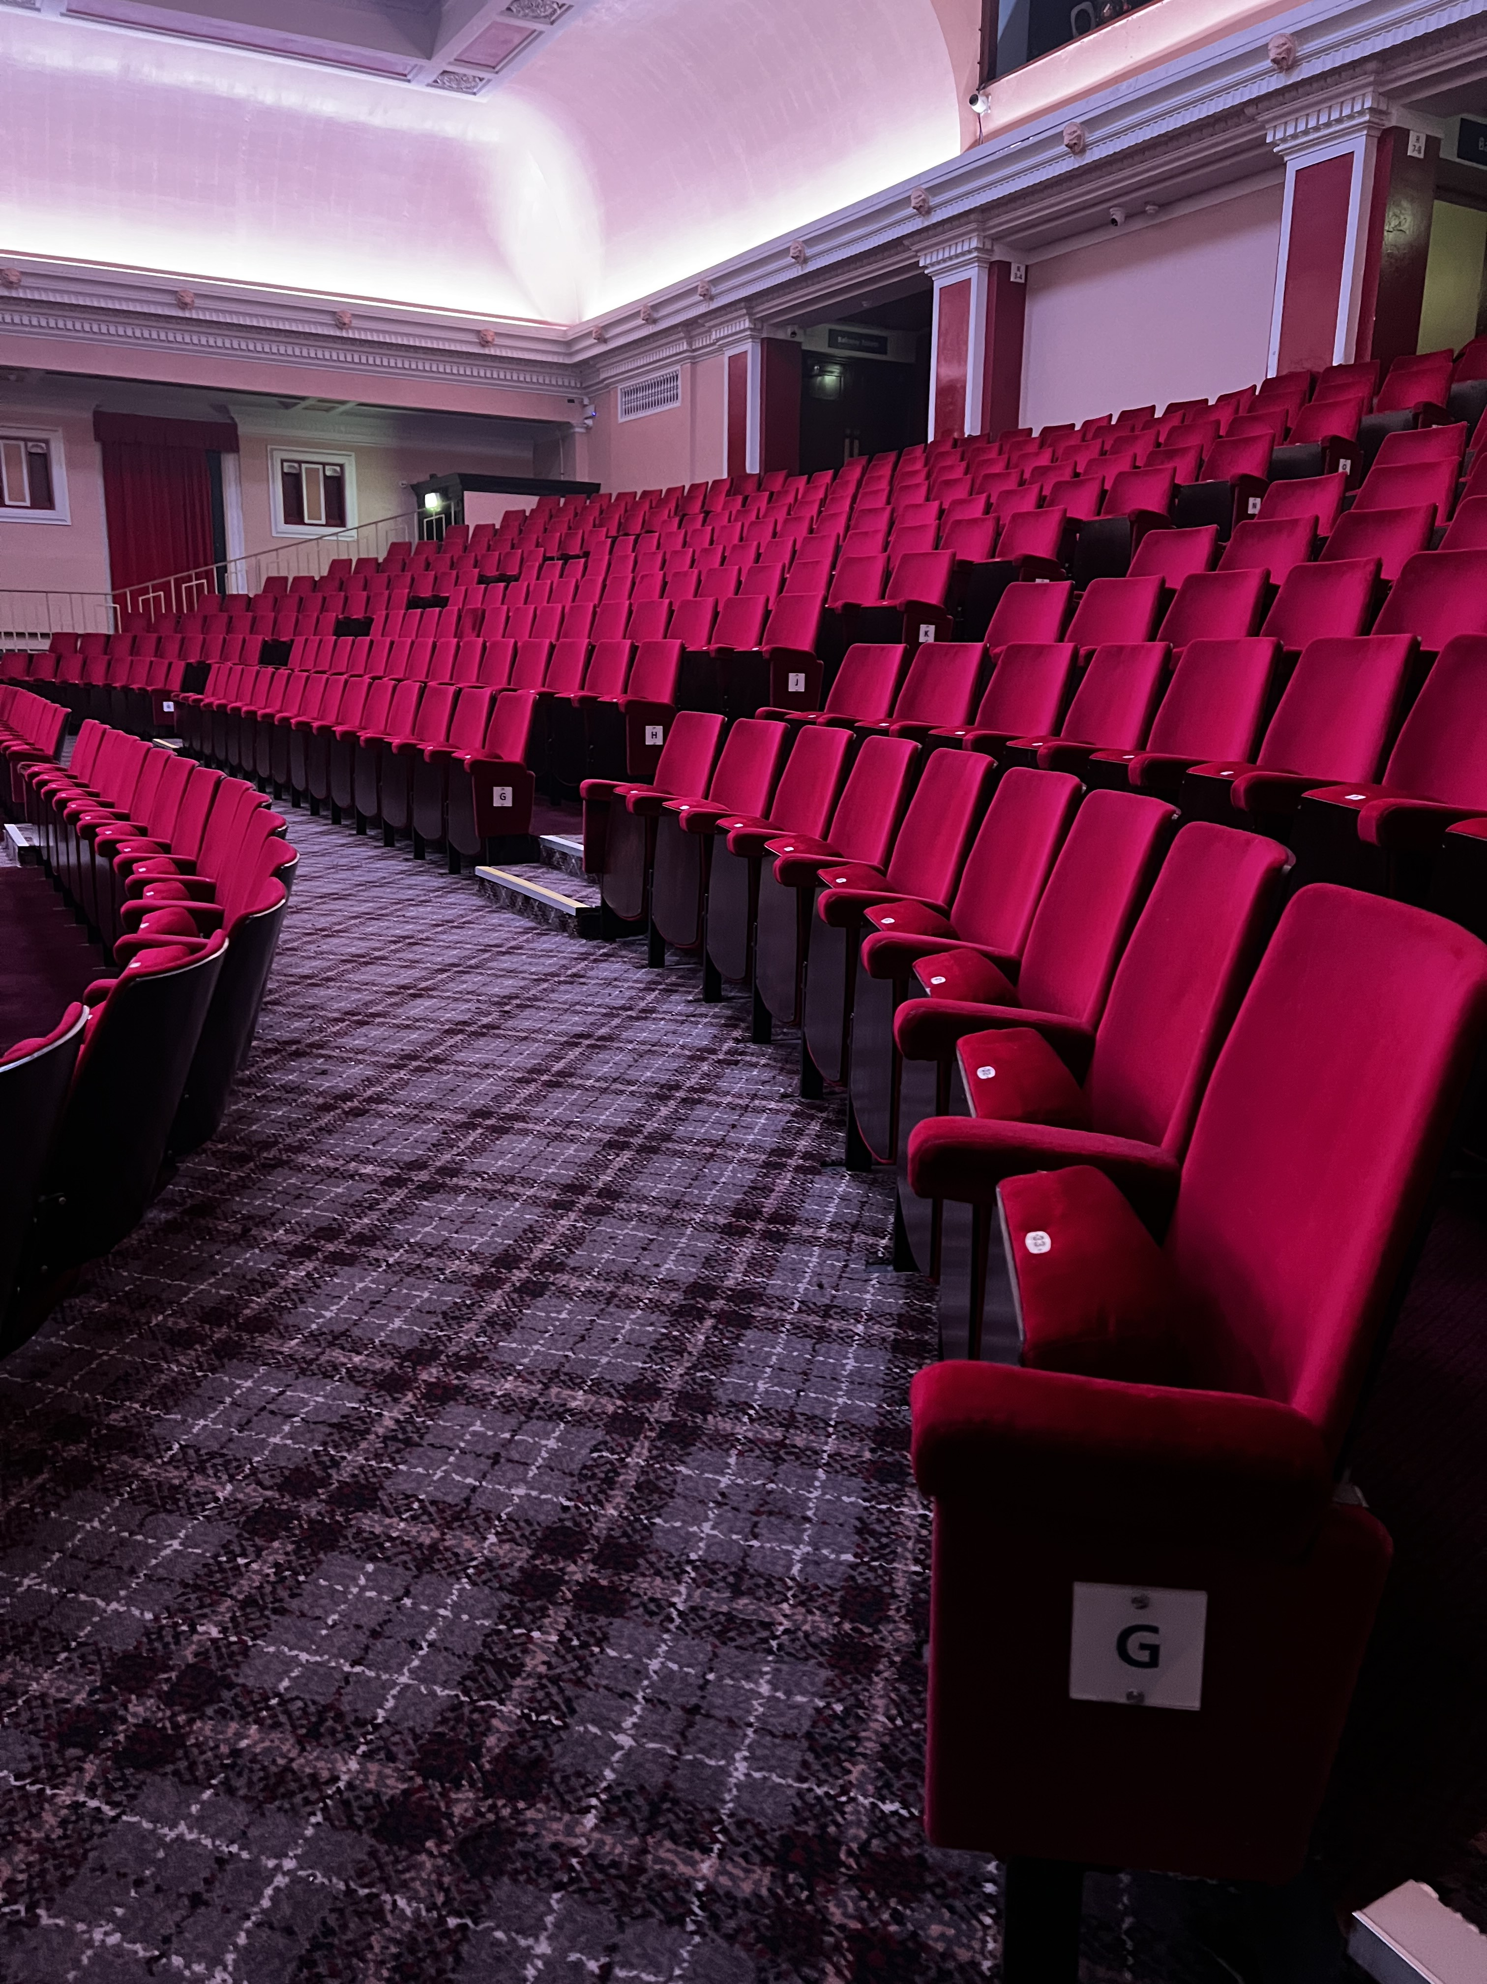
This photo shows Row G in our balcony area. This row has additional legroom and offers an unobstructed view of the stage.
Seat Dimensions (varies between Stalls and Balcony Seating)
Stalls
- Seat width: 410 millimeters
- Seat depth: 420 millimeters
- Armrest width: 425 millimeters
- Back width: 395 millimeters
- Back height: 500 millimeters
Balcony
- Seat width: 420 millimeters
- Seat depth: 425 millimeters
- Armrest width: 450 millimeters
- Back width: 470 millimeters
- Back height: 490 millimeters

Leg Room Clearance (varies between Stalls and Balcony Seating)
Stalls
- When the seat in front is not in use: 290 millimeters
- When the seat in front is in use: 220 millimeters
Balcony
- When the seat in front is not in use: 175 millimeters
- When the seat in front is in use: 175 millimeters

Accessible Toilet
We have one unisex accessible toilet located in the main foyer. It is step-free and kept locked. Please ask a member of our team outside for access; they have a RADAR key.
Audio Assistance
The venue has an Auracast system installed, a Bluetooth based sound induction system which works directly with Auracast enabled devices including earbuds, headphones and selected hearing aids or cochlear implants. Audio is easily accessed via a customer’s smart phone. Alternatively, the venue can provide a dedicated receiver on arrival. Please get in touch to make arrangements.
Performance Interpretation
Please get in touch if you require performance interpretation such as BSL or audio assistance. So you know, we'll need 31 days' notice prior to the show to make arrangements.
Assistance Dogs
We welcome assistance dogs in our venue. Please let us know in advance. We can look after your dog in a quiet office for the evening or you are welcome to keep them with you if required.
Strobe Lighting
Most shows include strobe or bright lighting. Signs will be up if there’s a lot of strobes in use. Contact us if you have concerns.
Medical Services
Medical staff are present at all events. They can be found in the First Aid Room or just speak to any staff member for help, and we will contact them for you. You’re welcome to bring medicine, food, drink, or equipment to manage a medical condition. Please let us know ahead of time if you can, on 0191 2496050
Smoking Area
If you need to smoke, staff can help you exit and return to the venue during the event. Please just let us know and we can help arrange this for you.
Personal Emergency Evacuation Plans (PEEPs)
We are committed to ensuring the safety of all our visitors, including those who may require assistance in the event of an emergency evacuation.
A Personal Emergency Evacuation Plan (PEEP) is a tailored plan designed to support individuals who may need help leaving the venue safely during an emergency, such as people with mobility, sensory, or cognitive impairments.
If you or someone in your group requires a PEEP, we encourage you to contact us in advance of your visit. This allows our team to understand your specific needs and prepare the appropriate support, including identifying safe evacuation routes and assigning trained staff to assist if required.
To arrange a PEEP or discuss your needs, please contact us via email on access@o2cityhallnewcastle.co.uk or via phone on 0161 249 6050 (Monday to Friday 12pm-4pm)
All information shared will be treated with sensitivity and in accordance with our privacy policy.
Exiting the Venue
When the show finishes, we recommend that you wait a little while before leaving.
This will help you avoid the busy crowds.
Our staff are on hand to help you leave our venue in the safest manner possible.
Please ask us if you need any help with directions, calling a taxi or any general assistance with leaving the venue.
Feedback
We value all feedback at the venue as it helps to continuously improve the experience we offer to all our guests. Following on from your visit we would be grateful for you to leave your feedback here.

